Fox J, Barthold S, Davisson M, Newcomer C, Quimby F, Smith A, eds. 2006. The Mouse in Biomedical Research, 2nd edition Elsevier Academic Press, San Diego, CA

Volume 3 - Normative Biology, Husbandry, and Models
Chapter 1 Gross Anatomy, pp. 1-22

QUESTIONS:
1. Where is the regio mentalis located?
a. Face
b. Skull
c. Neck
d. Chest
2. Where is the regio orbitalis located?
a. Face
b. Skull
c. Neck
d. Chest
3. Where is the regio supraorbitalis located?
a. Face
b. Skull
c. Neck
d. Chest
4. Where is the regio subhyoidea located?
a. Face
b. Skull
c. Neck
d. Chest
5. Where is the regio presternalis located?
a. Face
b. Skull
c. Neck
d. Chest
6. What is the number of vertebrae in the thoracic region?
a. 11-12
b. 12-14
c. 15-17
d. 13-17
7. What is the number of vertebrae in the sacral region?
a. 5-7
b. 4-5
c. 6-7
d. 3-4
8. What is the number of vertebrae in the cervical, lumbar and caudal region?
9. What is the name of the cranial nerve III?
10. What is the name of the cranial nerve VI?
11. What is the name of the cranial nerve IX?
12. What is the name of the cranial nerve XI?
13. What is the name of the cranial nerve IV?
14. How many lobes has the right lung?
a. 1
b. 2
c. 3
d. 4
15. How many lobes has the left lung?
a. 1
b. 2
c. 3
d. 4
16. Name the lung lobes.
17. How many lobes has the liver?
a. 2
b. 3
c. 4
d. 5
18. Name the liver lobes

Fill the numbers.

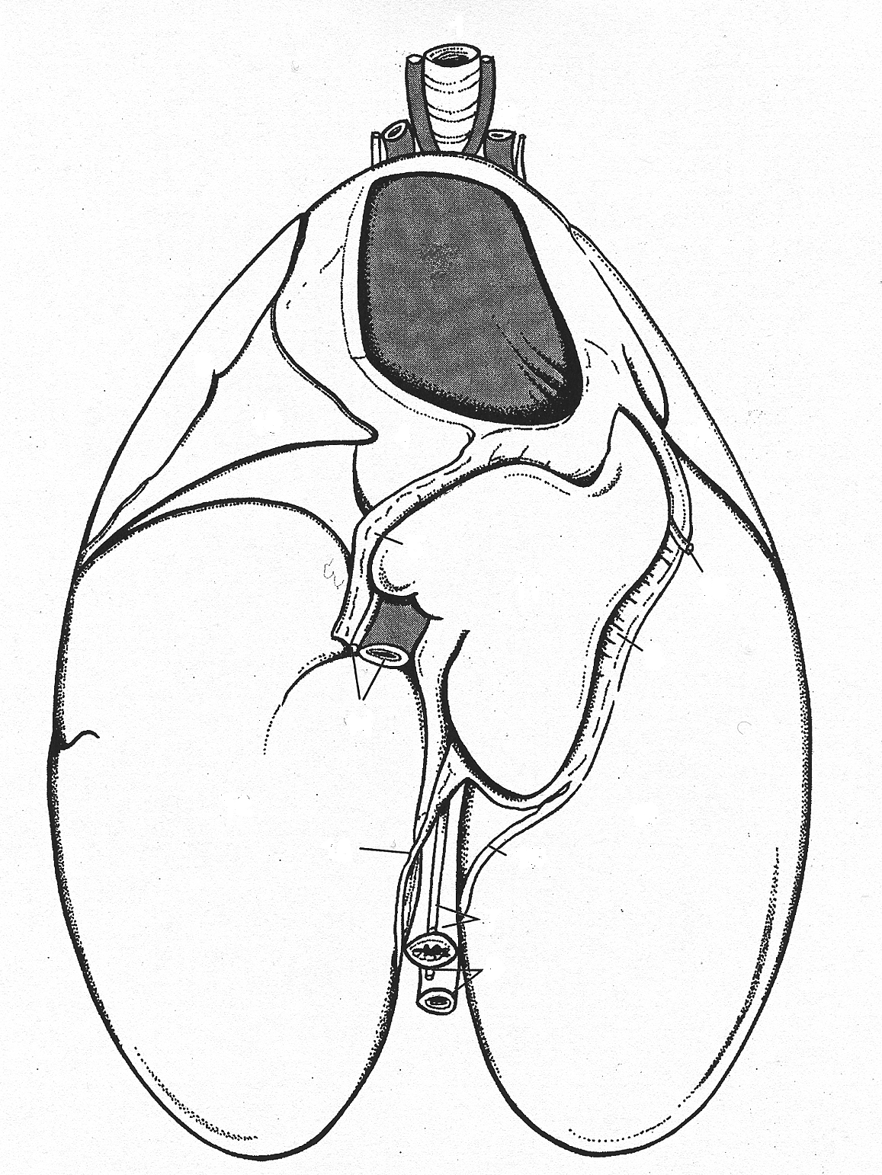
19
20

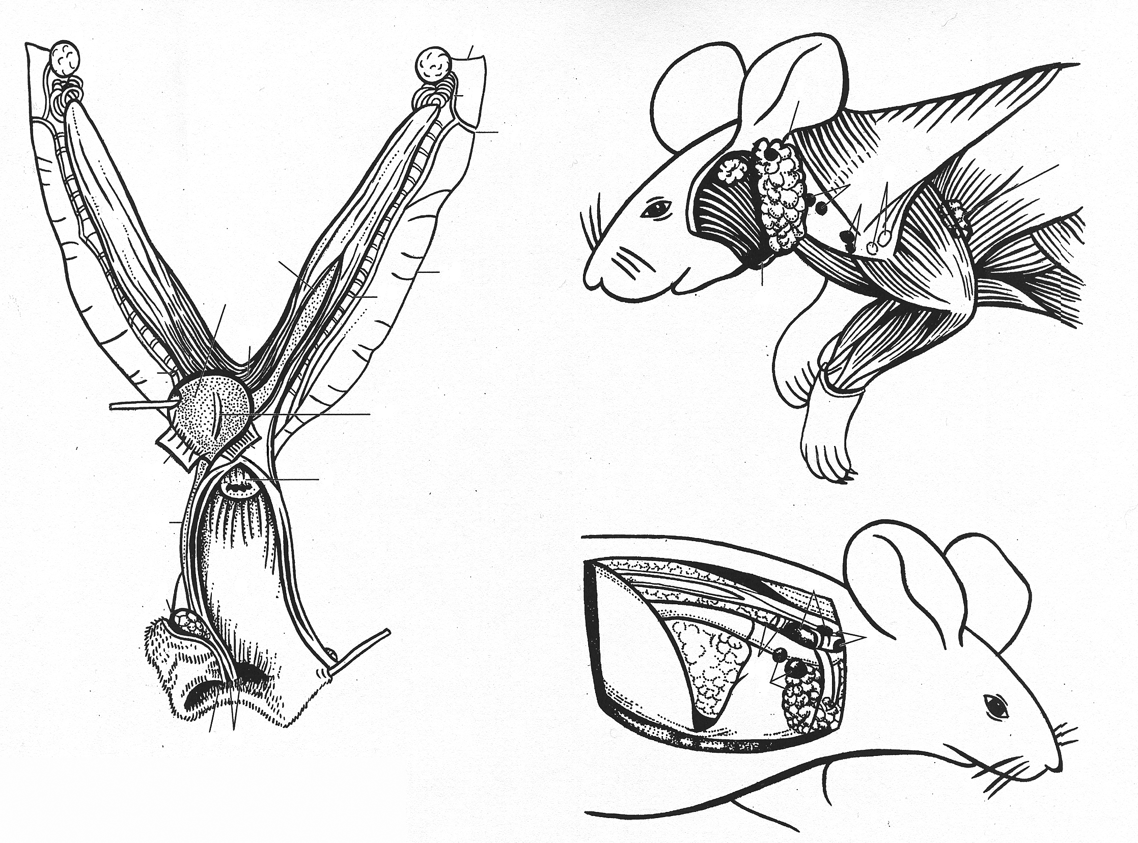
21
22
23
24

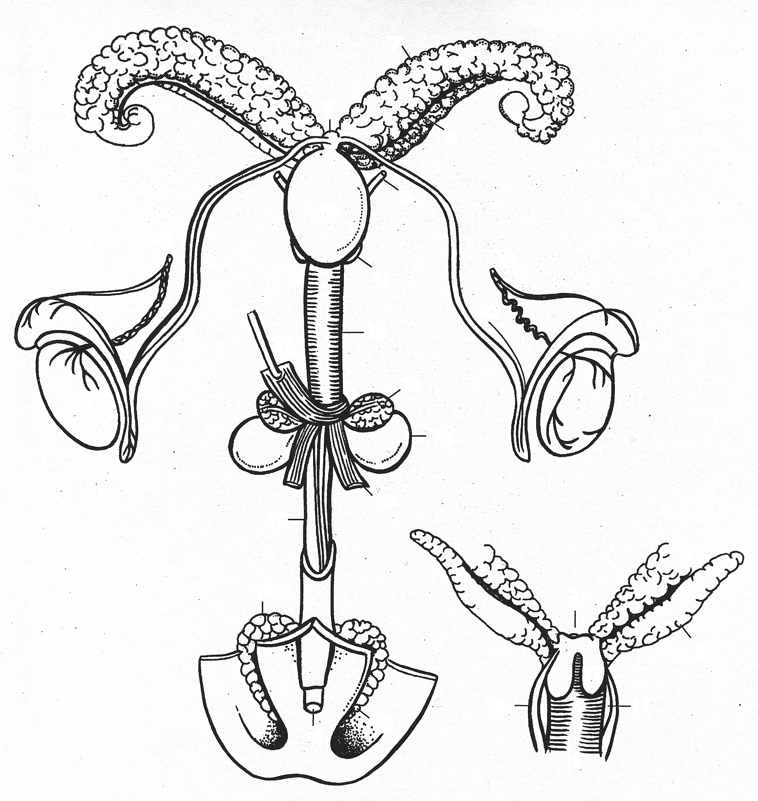
25
26
27
28
29
30

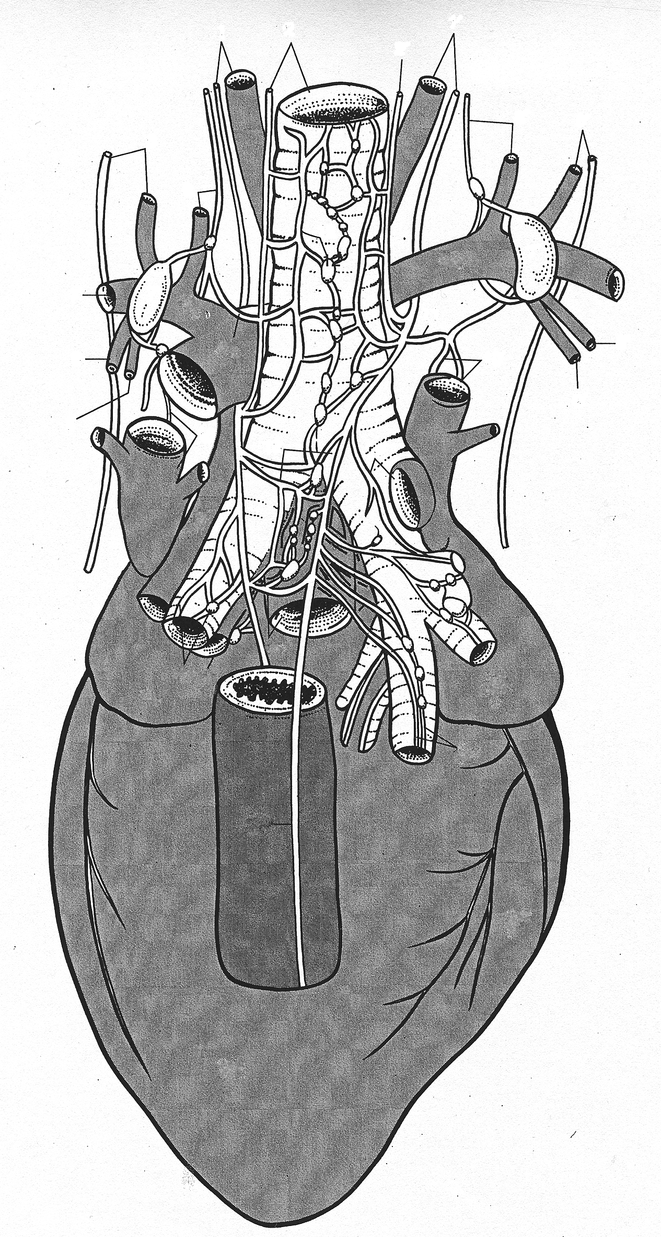
31
32
33
34
46

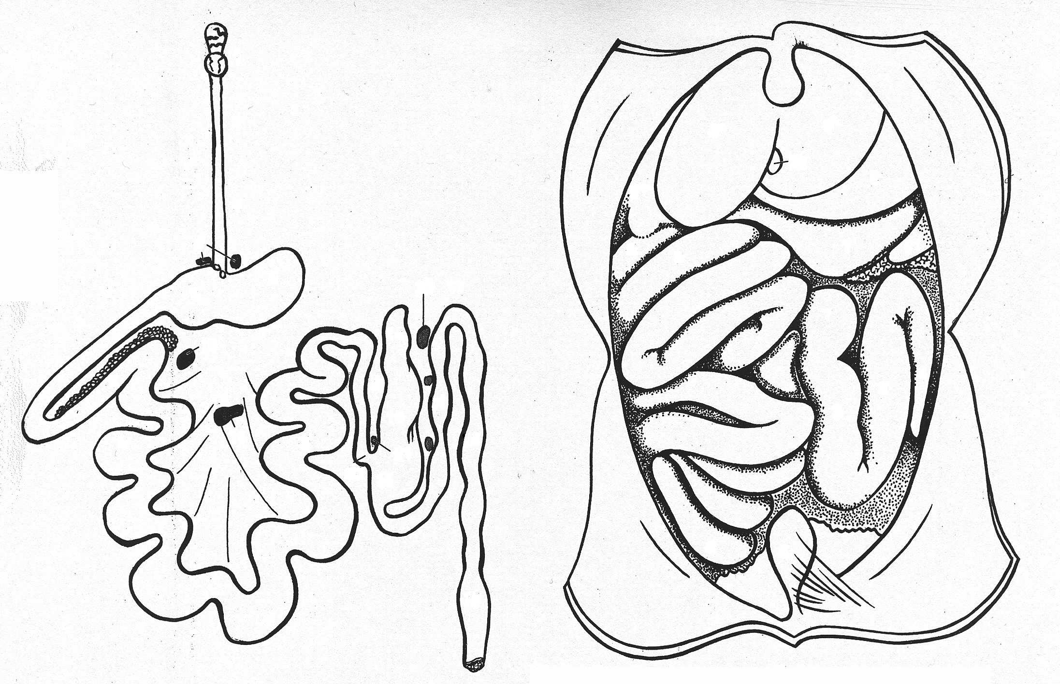
35
36

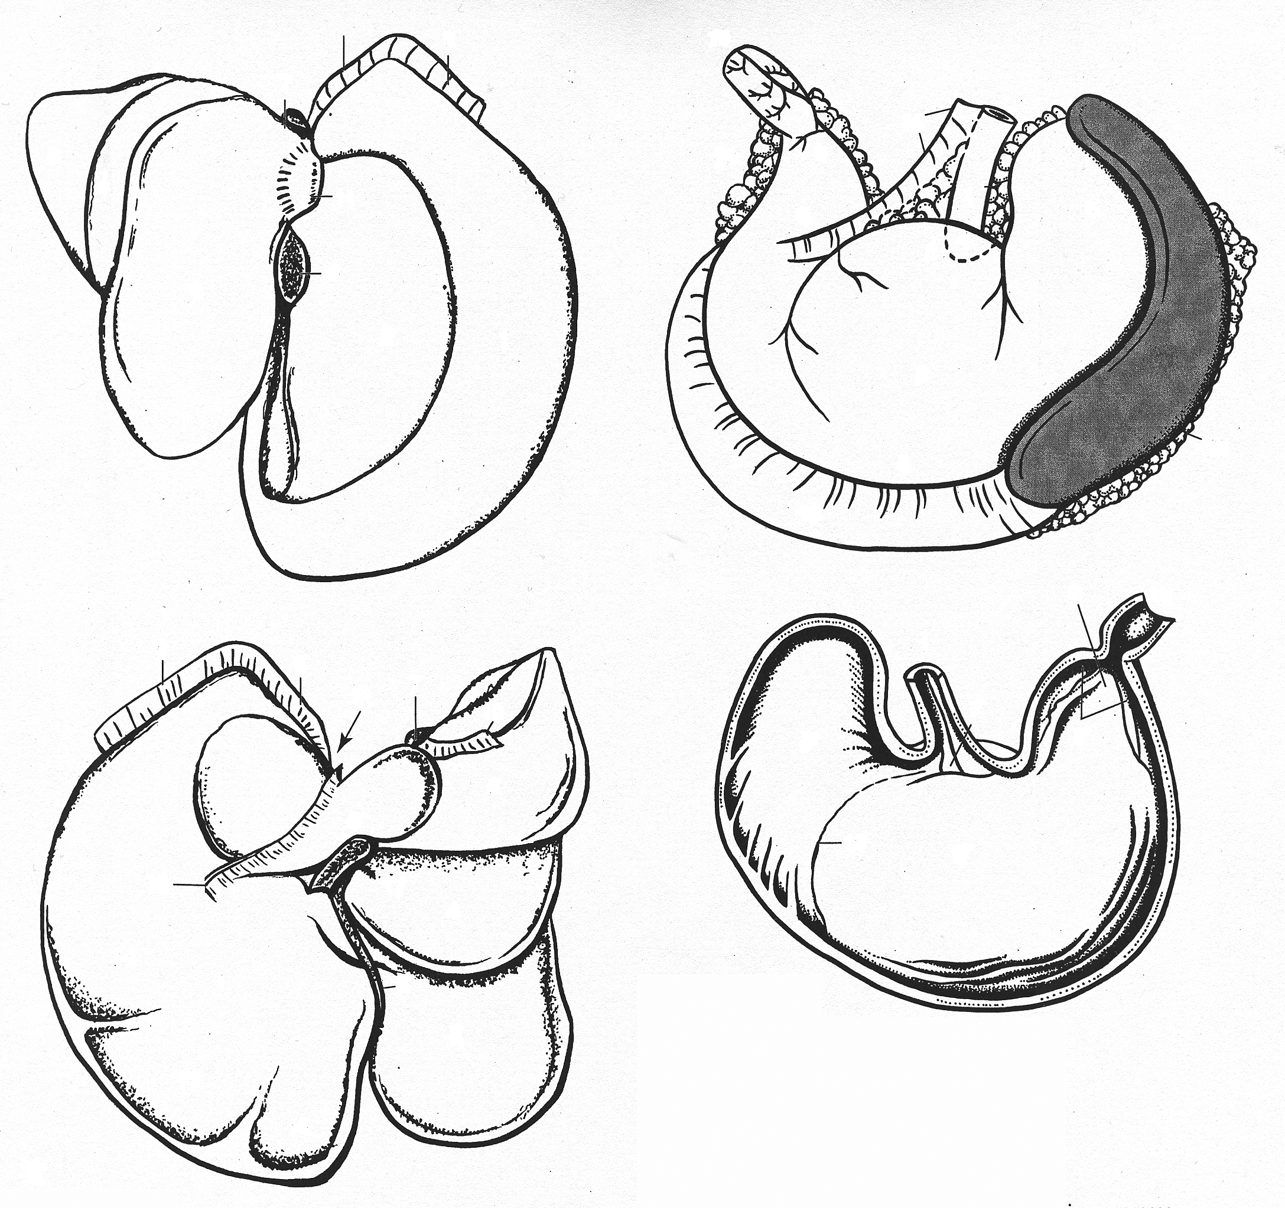
37
38
39
40
41

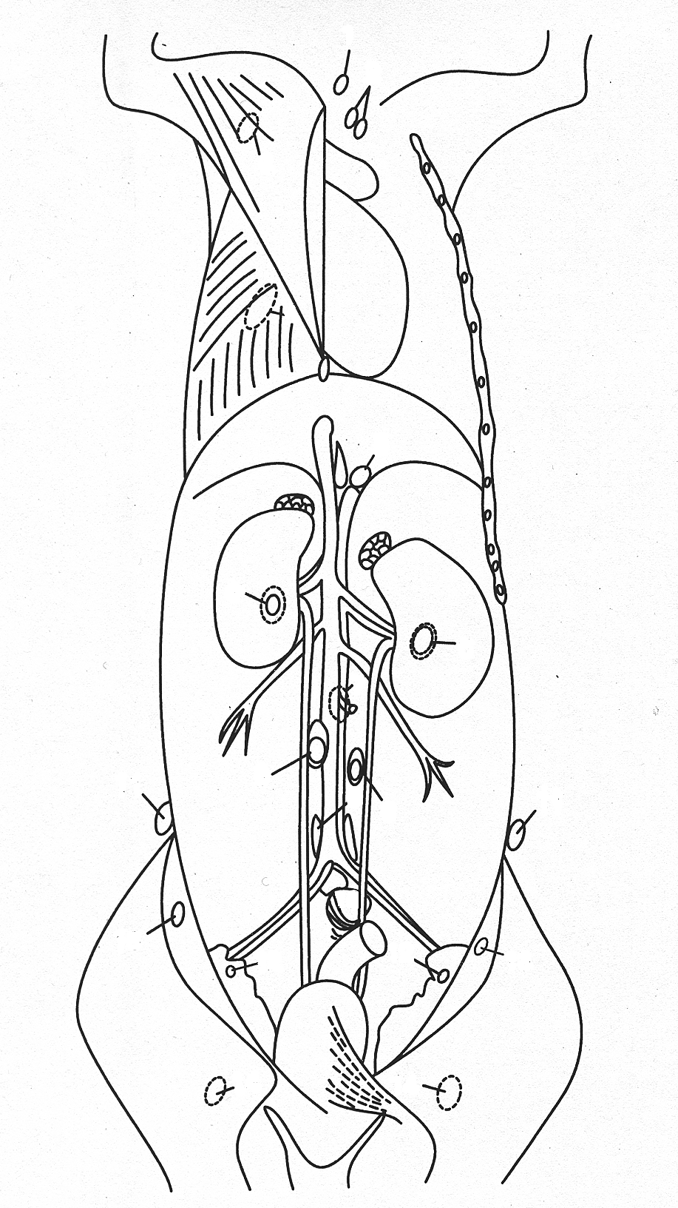
42
43
44
45

ANSWERS:
1. a
2. a
3. b
4. c
5. d
6. b
7. d
8. 7, 5-7, 27-30
9. oculomotorius/oculomotor
10. abducens
11. glossopharyngeus
12. accesorius
13. trochlearis
14. d
15. a
16. left lung not divided (pulmo sinister), cranial lobe (lobus cranialis pulmonis dextri), middle lobe (lobus medius pulmonis dextri), caudal lobe (lobus caudalis pulmonis dextri), and the subdivided accessory lobe (lobus accessorius pulmonis dextri)
17. c
18. right lateral lobe divide horizontally into anterior and posterior portions (lobus dexter lateralis hepatic), the median lobe subdivided into right and left portions by a deep bifurcation (lobus sinister medialis hepatis, lobus dexter medialis hepatic), the left lateral lobe undivided (lobus sinister lateralis hepatis), and the caudal lobe consisting of two leaf-shaped lobes dorsal and ventral to the esophagus at the lesser curvature of the stomach (lobus caudatus hepatic)
19. lung caudal lobe (lobus caudalis pulmonis dextri)
20. Herat (cor in pericardii)
21. oviduct (tuba uterina dextra)
22. cerviz (portio vaginalis uteri)
23. extraorbital lacrimal gland (glandula lacrimales extraorbitalis)
24. tracheobronchial lymph nodes (lymphonodi tracheobronchiales)
25. coagulating gland (pars anterior prostatae –glandula coagulationis)
26. vesicular gland (glandula vesiculosa)
27. epididymis head (caput epididymidis)
28. epididymis tail (cauda epididymidis)
29. bulbourethral gland (glandula bulbourethralis)
30. prostate (prostata pars dorsalis)
31. right anterior cava vein (vena cava cranialis dextra)
32. right cervical superficial artery (arteria cervicalis superficialis dextra)
33. common left carotid artery (arteria carotis communis sinistra)
34. left axilar artery (arteria axillaris sinistra)
35. gastric lymph node (lymphonodi gastrici)
36. gallbladder (vesica fellea)
37. left lateral lobe (lobus sinister lateralis hepatis)
38. median lobe, right portion (lobus dexter medialis hepatic)
39. median lobe, right portion (lobus dexter medialis hepatic)
40. impressio duodenalis
41. forestomach (pars epithelium stratificatum squamosum tunicae mucosae)
42. kidney lymph node (lymphonode enales)
43. lymph node popliteus (lymphonode popliteus)
44. deep caudal cervical lymph node (lymphonode cervicalis profundus caudalis)
45. lymph node axilar (lymphonode axillaris proprius)
46. posterior cava (vena cava caudalis)

