**Journal of the American Association for Laboratory Animal Science**

Volume 60, Number 2, March 2021

**ORIGINAL RESEARCH**

***Reproduction Biology***

**Shimozawa et al. Ultrasound-guided, Transabdominal, Intrauterine Artificial Insemination for Cynomolgus Macaques (*Macaca fascicularis*) Based on Estimated Timing of Ovulation, pp. 125-132**

Domain 3: Research

Primary Species: Macaques (*Macaca spp*)

SUMMARY

Introduction: Macaques require surgical retrieval of oocytes after exogenous hormone stimulation and the in vitro fertilization process can be onerous. AI is less invasive, doesn’t require complex procedures, and can yield multiple siblings from valuable sperm but is difficult due to complex cervical canals and cervical pockets and only results in a 30-58% pregnancy rate. IUI results in 33-50% pregnancy rate. Ovulation can be estimated with a decrease in serum estradiol and increase in serum progesterone but there is limited information on this in macaques. AI is dependent on successful sperm injection method and identification of ovulation thus IUI methods need further research.

Materials and Methods: Ovulation phase during menstrual cycle was monitored via a 360 immunoassay to determine estradiol and progesterone levels. Sperm was collected and a 90% motility was confirmed via microscopic evaluation. Procedure was performed @ preovulation stage: estradiol concentration exceeded 200pg/ml and progesterone was less than 0.1ng/ml.  IUI was performed via ultrasound guidance. An echogenic 23g needle was inserted using free hand technique and guided into the uterine cavity. Once position was confirmed the sperm was injected into the uterus and flushed with a special cleavage modified medium. Needle was removed and the abdomen was scanned for any internal bleeding associated with the procedure. Pregnancy was confirmed 4 – 5 weeks after via ultrasound.

Results: Changes in hormones noted a few days after IUI that confirmed ovulation occurred in 5 of 6 macaques which means 1 did not ovulate. Of the 5 that ovulated 4 became pregnant which was confirmed at week 4-5 after IUI. 1 miscarried, 2 were delivered and are healthy, and 1 is still pregnant.

Discussion: IUI method was successful in correlation with the ovulation of the animal. The 1 animal that did not get pregnant was due to the fact that it had an unusually long interval between menstrual cycles (61days), and the other animal did ovulate, but it was 14 days after IUI. Of the infants born their gestation length and birth weights were consistent with babies born to naturally mated animals in the colony. Thus the IUI didn’t cause any issues with the offspring or the mother. Could be a useful method for human infertility. Proved that only one injection is required for a successful pregnancy and previous reports of multiple injections are not required. Proves that pregnancy via this route if sperm is delivered 5 days prior to ovulation.

QUESTIONS

1. What is the normal gestation period and birth weight for cynomolgus macaques?
2. 145 days, 530g
3. 165 days, 330g
4. 185 days, 430g
5. 175 days, 630g
6. It is best to use IUI during pre-ovulation or ovulation
7. True or False: Ovulation is confirmed with an increase in estradiol and a decrease in progesterone

ANSWERS

1. b
2. Pre-ovulation
3. False; decrease in estradiol and increase in progesterone

***Husbandry***

**Moody et al. Using Paper Nest Pucks to Prevent Barbering in C57BL/6 Mice, pp. 133-138**

**Domain** 4: Animal Care

**Primary Species**: Mouse (Mus musculus)

**SUMMARY**: Providing in-cage resources, such as adequate nesting material, is important to allow lab mice to perform motivated behaviors, have some control over their environment, and to provide mental and physical stimulation. Literature suggests that adding resources can increase, decrease, or have no effect on aggressive behavior in mice. Nest building is an instinctual behavior in mice, and assessment of nest quality could indicate mouse well-being. This study investigated use of a compact nest material made of brown paper strips compressed into a puck shape as compared to brown paper strips dispersed in the cage in relationship to mouse behavior in a group setting.

27 male and 27 female C57BL/6NCrl mice were placed into same-sex groups of 3 in disposable cages with chip bedding, a single facial tissue, and received food and water ad lib. Mice were randomized to one of three treatment groups: single facial tissue, facial tissue + 8g puck of nesting material, facial tissue + 8g dispersed paper strips. Cage changed occurred on days 8 and 15, and the study was conducted over 15 days. Mice were videotaped for two hours after cage change and from 1700 to 2100 each day for the duration of study. Behavioral parameters were scored, including agonistic behavior, stereotypic behaviors, material manipulation, and latency to use nest material during two hours after cage changed. A nest scoring system was used for nest pictures.

All cages of females in control and paper strip groups showed evidence of barbering, whereas no females in the puck cages showed barbering. No barbering was noted in any males. Nest scores were higher in cages of mice win the paper strip group than control and puck groups. Puck cages had higher scores than control group. The number of stereotypic displacements was greater in female cages than male cages. Male mice spent more time manipulating materials than did females.

The results showed cages of mice with barbered mice displayed more chasing and mounting than did nonbarbered mice. Chasing and mounting may result in social subordination or dominance stress and is a welfare concern. Nest cores were higher in the paper-strip group, suggesting that this material resulted in higher-quality nests. Although puck cages showed only moderate nest scores, nest pucks protected mice from barbering, and these mice spent more time manipulating nest materials than did the paper-strip group. Perhaps a mix of paper strips and nest pucks would result in higher nest scores, more manipulation time, and reduced time performing agonistic and abnormal behaviors during the active dark phase. More research is needed to better understand relationships between types of nest materials, manipulation time, barbering, and agonistic behavior in C57BL/6 mice.

**QUESTIONS**

1.  Based on the literature, what volume of paper-strip nesting material is a sufficient amount for mice to build high-quality nests?

2.   There is limited knowledge examining in-cage placement of mouse resources. Based on the limited data, what is thought to be the preferred method to provide nest material to group-housed mice?

**ANSWERS**

1.  8-10 g of paper-strip nesting material is sufficient to build a high-quality nest based on the literature

2.   Limited data suggests dispersed material is preferred; clustered resources may induce more aggression and stereotypic behavior than dispersed resources.

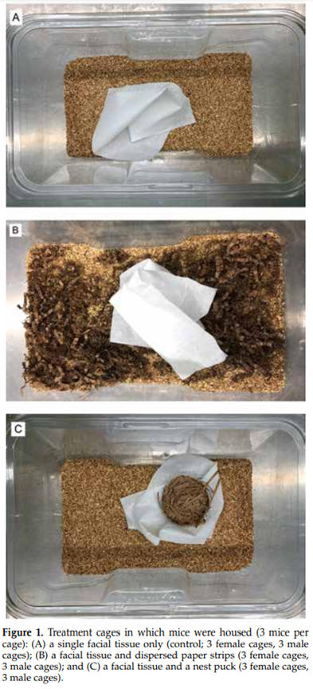

***Management***

**Marx et al. A Survey of Laboratory Animal Veterinarians Regarding Mouse Welfare in Biomedical Research, pp. 139-145**

Domain 2

Primary Species: Mouse (*Mus musculus*)

SUMMARY: The Animal Welfare Committee of the American Society of Laboratory Animal Practitioners surveyed laboratory animal veterinarians to obtain their opinions about the welfare of mice. Animal welfare is mandated by the federal government, championed by laboratory professionals and imperative for the continued acceptance of biomedical research by the public. The factors that determine the care and welfare of mice can be grouped into 5 categories: husbandry, clinical care, experimental use, regulatory oversight, and training. Veterinarians have a unique role in the use of mice in biomedical research as they are expected to engage in all aspects of an animal care and use program. 50% of the veterinarians surveyed believed that a lack of scientific data justifying improved standards of care is the main limitation to improving welfare for mice in research. 95% of veterinarians scored mouse welfare as acceptable to excellent with some areas for improvement. The areas where improvements can occur are: training of research staff, frequency of monitoring mice on experimental protocols, improvement in environmental enrichment, IACUC management of noncompliant situations, and the reliance of non-veterinarians performing clinical duties. The intention of this survey was to encourage self-reflection among individuals in the laboratory animal medicine community and lead to continued significant improvements in the welfare of mice in research.

QUESTIONS

1.  What year were rats, mice and birds used for research excluded from the AWA?

2.  T/F: The Guide strongly affirms the principle that all who care for, use, or produce animals for research, testing, or teaching, must assume responsibility for their well-being.

ANSWERS

1.  2002

2.   True

***Health Surveillance***

**Voros et al. Evaluation of Therapeutic Approaches for the Treatment of *Spironucleus muris* in Mice, pp. 146-151**

Domain 3: Research

Primary Species:Mouse (*Mus musculus*)

SUMMARY:*Spironucleus muris* is a protozoan parasite with a direct life cycle with an infectious cyst form. This parasite rarely causes mortality but can cause severe morbidity in young or immunocompromised mice. Currently the recommended treatment is to test and cull, or rederive the mice as this parasite should be excluded from colonies due to the potential to cause clinical signs and disrupt research reproducibility. Male CD1 mice naturally infected with S. muris were bred with naive CD1 females to generate naturally infected offspring via ingestion of parental feces. Mice received one of the following as treatment: metronidazole infused into sucralose gel cup, fenbendazole infused into sucralose gel cup, metronidazole & fenbendazole infused into sucralose gel cup, or acidified water infused into sucralose gel cup. Results indicate that none of the drugs given at the tested doses are efficacious for eradication of S. muris, *but*they are a potential option for reducing the burden of parasites in individual animals. As a result the recommendation for eradication of S. muris still remains testing and culling (or rederivation) of infected mice along with proper decontamination of contaminated rooms and equipment.

QUESTIONS

1. What is the mechanism of action of Metronidazole?

* 1. Disrupts RNA synthesis resulting in antibiotic and anti-protozoan properties
  2. Disrupts DNA synthesis resulting in antibiotic and anti-protozoan properties
  3. Disrupts cell wall structure resulting in antibiotic and anti-protozoan properties

2. What is the lifecycle of *Spironucleus muris*?

a. Direct with the cyst being the infective form

b. Direct with the trophozoite being the infective form

c. Indirect with the cyst being the infective form

ANSWERS

1. b

2. a

**Clark et al. Antibody Titers and Seroconversion Kinetics of Outbred Swiss and Heterozygous Nude Soiled-bedding Sentinels for Murine Norovirus and Mouse Hepatitis Virus, pp. 152-159**

Primary Species: Mouse (*Mus musculus*)

Domain 4

SUMMARY:Soiled bedding sentinels are still a common way to evaluate colony health status. This institution was using CRL: CD1(ICR)-Elite (CD-1-Elite), but they were both expensive and sometimes supply-limited. Nude mice are produced by mating male nude mice and heterozygous female nude mice (e.g. CRL:NU-*Foxn1*­nu/+ or Het-nude) because female nude mice have poor lactation and cannot support their litters. Using Het-nudes would be a reduction in use of animals as many are generated due to the breeding paradigm that may not be used as breeders. In this study, Het-nudes were exposed to dirty bedding from MNV and MHV positive animals, and blood was collected for serology 3, 9, 12, and 19 weeks later. Antibody titers did not differ significantly between the two strains of mice tested, but they did increase over the study period. Het-nudes present a viable alternative to CD-1-Elite mice for viruses that are transmitted well via the fecal-oral route.

QUESTIONS

1. What is the breeding scheme for generating nude mice?
   1. Homozygous breeding (male and female)
   2. Homozygous nude male, Het-nude female
   3. Het-nude male, homozygous nude female
   4. Het-nude male, Het-nude female
2. How did the antibody titers for MHV and MNV change from 3-19 weeks of exposure in Het-nude and CD1-Elite mice?
   1. Titers were steady
   2. Titers decreased
   3. Titers increased
   4. Het-nudes did not have a titer for MNV and MHV after exposure
3. What was a primary concern about using Het-nudes as sentinels?
   1. They are not raised in isolators, so they don’t have the same health status as CD-1-Elite
   2. Smaller thymus than wild-type mice, may be immunodeficient, affect seroconversion
   3. No concerns

ANSWERS

1. b
2. c
3. b

**O’Connell et al. Evaluation of In-cage Filter Paper as a Replacement for Sentinel Mice in the Detection of Murine Pathogens, pp. 160-167**

Domain 4: Animal Care

Primary Species: Mouse (*Mus musculus*)

SUMMARY:This paper evaluated the efficacy of pathogen detection using filter paper in the bottom of dirty sentinel cages. The results of the filter paper testing are compared against the pathogen detection of a live mouse exposed to dirty bedding. There are several advantages for using filter paper compared to other techniques, the most obvious being consistent with the 3 R’s and the reduction of animals used in the sentinel program. The use of a colony mouse requires using a test animal (possibly expensive) and this has been linked to false negatives. Reasons for false negatives in colony animals include the organism tested for, prevalence of the infection within the colony and the strain/age of the colony animals. Contact sentinels has demonstrated success in pathogen detection, however it is challenging to do in large colonies and there is the risk of spreading a pathogen. Soiled-bedding sentinels are more practical than contact sentinels, but the testing is limited to pathogens that are fecoorally transmitted. Microisolation in modern caging systems limits the spread of pathogens leading to lower prevalence levels and making them detectable through dirty bedding more difficult. PCR Environmental sampling from exhaust air duct prefilters offers advantages over sentinel bedding including the detection of *Helicobacter spp*., ectoparasites and respiratory pathogens. This form of testing is not compatible with all caging systems. Cage lid filter paper has proven efficacy for pathogen detection but requires the shaking of the cage on a regular basis. This study placed two types of filter papers in cages, contaminated the cages with dirty bedding once a week for 8 weeks and tested the filter paper for a suite of common pathogens at 4 weeks and 8 weeks including MHV,MNV, MPV, TMEV, *Helicobacter spp*., *Syphacia obvelata* and *Aspiculuris tetraptera*. The two filter papers were Sentinel EAD filter (Allentown Caging) and Reemay filter paper (Alternate Design). The source of the pathogen bedding was from pet store mice that had their health status established at the beginning of the studied and tested again at the end of the study. Sentinel mice failed to detect *Helicobacter spp*., identified *S. obvelata* in 4 of 7 cages at both time points, and *A. tetraptera* in 3 of 7 cages at the 8 week time point. Both filter papers detected all pathogens at both time points but not in every cage for MNV, MHV, TMEV and *A. tetraptera*. A major advantage of using filter paper is that they are compatible with all rack and caging systems.

QUESTIONS

1. What are some reasons for false positives when using colony mice for a sentinel program?
2. In modern IVC’s why does a lower pathogen prevalence make the detection of pathogens more difficult when using dirty bedding sentinels?
3. What is a possible explanation for finding *S. obvelata* at the one month time point and not *A. tetraptera* in the mouse sentinels?
4. What pathogen was detected by filter paper but not in the sentinel mouse?
5. What are examples of pathogens that can be detected in exhaust air duct pre-filters compared to sentinel bedding animals?

ANSWERS

1. Reasons for false negatives in colony animals include the organism tested for, prevalence of the infection within the colony and the strain/age of the colony animals
2. A lower prevalence leads to dilution of the pathogen when bedding is collected from a large number of cages on the rack.
3. *S. obvelata* has life cycle of 11-15 days, embryonates in 5-20 hours vs *A. tetraptera* which has a life cycle of 25 days and embryonates in 5-8 days.
4. *Helicobacter spp.*
5. *Helicobacter spp*., ectoparasites and respiratory pathogens.

**Robertson et al. West Nile Virus Seroprevalence in an Outdoor Nonhuman Primate Breeding Colony in South Florida, pp. 168-175**

**Domain 1**: Management of Spontaneous and Experimentally Induced Diseases and Conditions

**Primary Species**: Macaques (*Macaca spp.*)

Secondary Species: Baboon (*Papio spp.*)

**SUMMARY**: West Nile virus (WNV) is a zoonotic virus in the family Flaviviridae.  Transmission most commonly occurs by a mosquito vector (Culex spp. most common).  Wild birds are the primary reservoir and amplifier host, and mammals (humans, NHP, and horses) are considered dead-end hosts.  Infections are commonly asymptomatic but febrile illness may occur.  Retinopathy, encephalitis, meningitis, and death is less common but may occur in immunocompromised individuals.  This study investigated WNV seroprevalence in rhesus macaques, cynomolgus macaques, and hamadryas baboons housed outdoors at The Mannheimer Foundation in South Florida, in which the environment provides excellent conditions for mosquitos.  Outdoor enclosures included field cages, corrals, and corncribs.  Sampled primates were anesthetized with ketamine IM, and blood collected by femoral venipuncture.  The presence of WNV IgG antibodies was determined by serum neutralization assays.  Confirmatory testing was randomly performed on a group of samples by plaque reduction neutralization testing.  Seroprevalence was significantly higher in baboons than rhesus or cynomolgus macaques.  Baboons were thought to be preferentially targeted by mosquitos because of their larger body size and therefore greater generation of carbon dioxide.  The frequency of seropositivity increased with age but not with sex or site tested.  Exposure to WNV did not appear to significantly impact colony health, so routine PCR or serologic testing was not recommended for most colonies.  However, it was recommended that with any NHP presenting with nonspecific neurologic signs, WNV should be considered as a differential diagnosis.  The authors also recommended that screening for WNV occur before studies in which viremia or antiviral antibodies could confound results.  Mosquito abatement plans and vigilant sanitation practices to decrease mosquito and avian activity were also recommended.

**QUESTIONS**

1. The proper shipping name for a blood sample placed into this packaging for WNV testing is?
   1. UN 2814, infectious substance, affecting humans
   2. UN 2900, infectious substance, affecting animals
   3. UN 3373, biological substance, category B
   4. UN 3373, infectious substance, affecting humans

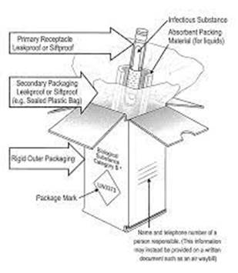

1. Which of the following is typically a principal mosquito attractant?
   1. Carbon dioxide
   2. Oxygen
   3. Methane
   4. Octanol
2. Which of the following viruses is NOT in the family Flaviviridae?
   1. West Nile virus
   2. Dengue virus
   3. Zika virus
   4. Chikungunya virus
3. According to the 6th edition of the BMBL, which BSL level is recommended when working with West Nile virus in the laboratory?
   1. BSL 1
   2. BSL 2
   3. BSL 3
   4. BSL 4

**ANSWERS**

1. c
2. a
3. d
4. b

***Anesthesia***

**Fuetsch et al. Injection Reactions after Administration of Sustained-release Meloxicam to BALB/cJ, C57BL/6J, and Crl:CD1(ICR) Mice, pp. 176-183**

Domain 3

Primary Species: Mouse (*Mus musculus*)

SUMMARY:Sustained release meloxicam (MSR) is an NSAID that may provide as long as 72hours of analgesia after a single SQ dose in rats and mice. Previous reports have not assessed potential adverse reactions.  Nor are Injection site reactions mentioned in the data sheet for MSR. This study looked at adverse injection site reactions in conjunction with strain or sex and reactions varying histologically over time.

108 mice from three different strains were used: 36 Crl:CD1(ICR), 36 BALB/cJ and 36 C57BL/6J. Each group half female and half male.  Mice were assigned to one of three groups: single dose of MSR, Single dose of standard-formulation meloxicam (MEL) and sterile 0.9% saline (SC). Half the mice from each treatment group was euthanized and necropsied on day 7 post injection and the other on day 14 post injection. Animals were observed daily for general health, which included an exam of the injection site and surround  tissue starting the day after injection. The observer used a 5-point scoring system (0 = no visible reaction/palpable mass - 4= moderate to severe alopecia and erythema with full thickness ulceration/ palpable mass, borders defined, measurable with full thickness ulceration) to assess the presence of erythema and mass at the injection site. At necropsy, the injection site and organs were evaluated for gross abnormalities and histopathology was performed to characterize inflammation.

Results: Daily average erythema and mass scores showed that MSR mice had significantly higher scores than MEL and SC animals, regardless of strain or treatment day. The median time to first erythematous lesion score of greater than or equal to 1 in the MSR treatment group was 3 days, showing a consistent, highly significant difference from the SC group.  The median time  to first mass lesion in MSR treatment group was 2 days and differed significantly from  the SC group.  Severity at day 7 was significantly greater in the MSR group, regardless of sex or strain than in the MEL or SC  groups.  Inflammation at 14 da was significantly greater in the MSR  group regardless of strain or sex than in the MEL or SC groups.  No significant differences in the occurrence of erythema lesions, mass lesions or time to first mass or erythema was noted between sex,  but the severity of inflammation at 14 da was significantly greater in MSR treated females (due to CRl:CD1(ICR) females).  And lastly, the incidence of erythematous lesions was significantly lower in BALB/cJ than in the other strains.

Discussion: MSR leads to the development of erythematous and mass lesions more frequently than MEL or SC. Resolution of these issues may take over 14 days. Possible explanation for lack of adverse reactions to MSR in the literature include the amount of time between injection to the initial emergence of the lesion (2 day for palpable mass and 3 day for erythema), lesions were only detectable through palpation and not visualization, lesions were also not directly at the injection site, but where drug may have pooled into SQ tissue, or lesions may be attributed to other etiologies like barbering or fight wounds.

Careful consideration should be exercise when prescribing and administering MSR as a treatment option.

QUESTIONS

1. What species are reported to have reactions to MSR?
   1. macaques
   2. Sheep
   3. Hispaniolan parrots
   4. American Flamingo
   5. A &C are correct
2. T or F: Alopecia and ulcerative lesions in the C57BL/6J strain could be mistaken for ulcerative dermatitis, which is a common condition of this strain?
3. T or F: BALB/cJ strain is known to exhibit bias towards a Th1-type immune reaction and C57BL-6J predominately exhibits a Th2-type immune reaction
4. Possible pros of a sustained release formulation of meloxicam include all of the following except:
   1. Reduction in the amount of handling
   2. Reduction in the amount of labor needed post operatively
   3. Reduction in risk of postoperative injury
   4. All of the above are correct

ANSWERS

1. e (sheep and flamingos have little or no observed reactions)
2. True
3. False: BALB/cJ have a bias for Th2 and C%7BL-6J for Th1
4. d

**Hampton et al. Sedation Characteristics of Intranasal Alfaxalone in Adult Yucatan Swine, pp. 184-187**

Domain 2, Task 2: Minimize or eliminate pain and/or distress

Primary Species: Pig (*Sus scrofa domestica*)

SUMMARY: This article sought to evaluate a less invasive method (intranasal) of administering alfaxalone for sedation in adult Yucatan swine. Although IM and IV techniques have been studied and validated for use, there is concern about the handling and restraint needed for these methods of administration, as well as the potential anxiety and pain caused upon injection. Due to the rich vascularization of the nasal cavity, intranasal administration results in rapid absorption. In addition, the blood-brain barrier is bypassed due to the olfactory and trigeminal neural pathways, allowing for rapid integration. Intranasal midazolam, a benzodiazepine which acts on the GABAAreceptor, has been used successfully in swine for sedation; alfaxalone, a neurosteroidal compound which acts as a direct agonist to the GABAA receptor, was hypothesized to produce the same sedation, anesthesia, and muscle relaxation through the intranasal route as seen in the IM and IV routes. The authors reported sedation in adult Yucatan swine at both the 1 mg/kg and 2 mg/kg doses, but the pigs were easily roused by loud noises or noxious stimuli (i.e., a needle stick to the ear pinnae), making IN alfaxalone by itself insufficient to perform handling or clinical procedures. The low doses were chosen due to the concentration of alfaxalone available in the United States (10 mg/ml) and the anticipated difficulty in administering large volumes intranasally.

QUESTIONS

1. Which of these pairs of drugs have similar mechanisms of action? More than one answer may be correct.
   1. Alfaxalone and diazepam
   2. Midazolam and pentobarbital
   3. Diazepam and midazolam
   4. Alfaxalone and pentobarbital
2. Describe the type of study where each subject serves as its own control.
3. Explain the following:
   1. A type I error of 5%
   2. A power of 80%
   3. An effect size of 1.2

ANSWERS

1. All of the above have similar MoA with their counterparts – they all have an effect on the GABA receptor, either by directly stimulating it (alfaxalone and pentobarbital) or making it more efficient and receptive to neurotransmitters (midazolam and diazepam).
2. Single-subject study. In a crossover study, each participant receives the same treatment as everyone else in a sequential fashion, but the order is randomized. In the study detailed in this paper, each animal received one dose then went through a 60d washout period before receiving the second dose.
3. See below:
   1. 5/100 times the result will be a false positive (the null hypothesis will be rejected)
   2. The study has an 80% chance of ending up with a statistically significant treatment effect if there really was an important difference between treatments
   3. Effect size is a quantitative measure of the magnitude of the experimental effect. The larger the effect size the stronger the relationship between two variables – an effect size of 1.2 is considered large.

**Fitz et al. Pharmacokinetics of Buprenorphine and Sustained-release Buprenorphine in Common Marmosets (*Callithrix jacchus*), pp. 188-194**

Domain 2: Management of pain and distress; K5. Pharmacological interventions for pain and distress and their effects on physiology, including age and species differences for such interventions, and depth and duration of analgesia provided by such interventions

Domain 3: Research; K12. Replacement, Reduction, and Refinement

Secondary Species: Common Marmosets (Callithrix jacchus)

Abbreviations: BUP, buprenorphine HCl; BSR, sustained-release buprenorphine

SUMMARY: As an opioid with a favorable safety profile and relatively long duration of action, buprenorphine is the most commonly used opioid in most NHP species. Buprenorphine (BUP) and sustained-release buprenorphine (BSR) pharmacokinetics have not been described in marmosets as in cynomolgus and rhesus macaques. Longer duration of action improves animal welfare by reducing each of the following: handling required, number of injections per animal, adverse effects at peak plasma concentration, and troughs of possible inadequate analgesia. General New World NHP guidelines recommend lower dosages of BUP for marmosets due to profound adverse events seen at higher dosages (examples given: respiratory depression, apnea, death) and seen when BUP is combined with anesthetics (examples given: alfaxalone, isoflurane). This study investigated plasma concentrations of buprenorphine in one group of 6 common marmosets at 5, 20, 30 min and 1, 2, 4 , 8 h post-intramuscular injection of BUP in the right quadriceps or a second group at 15, 30 min and 1, 8, 24, 48, 72 h post-subcutaneous injection of BSR on the right ventral abdomen. Blood samples were taken at time points given from femoral venipuncture and marmosets evaluated for general wellbeing and scored 1 to 4 for signs of ataxia, sedation, and injection site reaction (Fig. 1). Hypotheses were that concentrations would remain above plasma threshold (>0.1 ng/mL) for 6h to 8hr after a single BUP 0.02mg/kg IM and 72 h for BSR 0.2mg/kg SC.

All resulting adverse effects were temporary and did not require treatment. All BUP group received mild ataxia scores at least at one timepoint and moderate sedation scores at least at two time points. Two of 6 BUP group marmosets received moderate ataxia score at least at one timepoint. Only 1 marmoset in the BSR group received a mild ataxia score at one timepoint and another had irritated skin at the injection site likely from scratching. All BSR group received mild sedation scores. BUP IM injections caused peak concentrations in 5 of 6 marmosets at the 5 min timepoint and 2 experienced a second peak. BSR SC injections reached peak levels more slowly but reached plasma threshold of 0.1 ng/mL by 15 min. The 3 female marmosets in the BSR group had lower plasma concentrations at 24, 48, and 72 h time points compared to the 3 males in the same group.

All time points of BUP and BSR groups resulted in plasma concentrations of buprenorphine above the plasma threshold, supporting the study hypotheses. More studies needed to provide more precise end plasma concentration-time curves. The gender difference in the BSR group was not expected and the cause is unknown but thought to be due to factors such as differing circulating hormones, estrus cycle variations, body composition, or metabolism of cytochrome P450.

Variation in plasma concentrations after IM BUP have been reported in other species and may be due to factors affecting absorption as: lipophilicity of compound, muscle mass, vascularity, or accidental injection into adipose or fascial tissue. This study assumed minimal therapeutic plasma threshold of buprenorphine in humans (0.1 ng/mL) as effective for marmosets and authors point out this is a limitation of the study as well as not testing other commonly used BUP dosages (examples given 0.005 mg/kg, 0.01 mg/kg). Lower dosages will need more frequent dosing and monitoring. BUP rapid onset and higher initial concentrations that may be more effective faster in comparison to BSR and are its main advantages. The main advantage of BSR is the longer duration of action greater than 3 days with a better safety profile compared to BUP. Both BUP and BSR may be used safely for analgesia in common marmosets and BSR provides a long-acting and safe protocol refinement option.

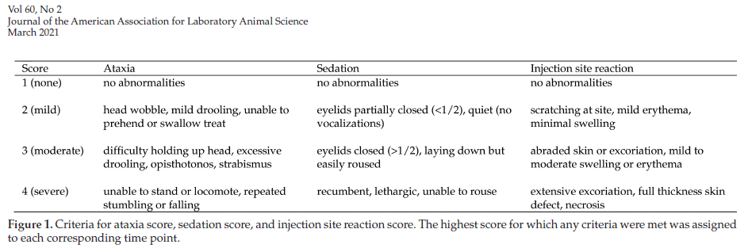

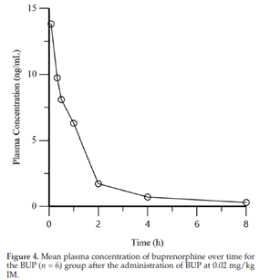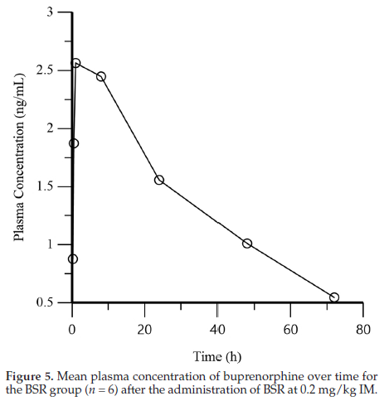

QUESTIONS

1.   Did BUP or BSR have fewer adverse reactions observed?

a. BSR

b. BUP

2.   Did BUP or BSR have a significant gender difference? What is an important discussion point that may explain why?

a. BUP, P450 metabolism

b. BUP, body weight

c. BSR, body weight

d. BSR, P450 metabolism

3.   Further studies on BUP and BSR are needed in marmosets for which of the following reasons presented in the discussion?

a. To provide more precise data for the beginning of the buprenorphine plasma concentration-time curves in common marmosets.

b. Establish maximum therapeutic threshold for plasma buprenorphine in common marmosets of both genders.

c. Establish minimal therapeutic threshold for plasma buprenorphine in common marmosets of both genders.

d. Establish reliable analgesiometric tests in common marmosets.

4. Which group had an injection site irritation?

a. BSR

b. BUP

ANSWERS

1. a
2. d
3. c
4. a

***Experimental Use***

**Celeste et al. Effects of Cling Film Draping Material on Body Temperature of Mice During Surgery, pp. 195-200**

Domain 3: Research

Primary Species: Mouse (*Mus musculus*)

SUMMARY: Most surgical patients, especially small rodents, become hypothermic due to cold exposure and anesthetic-induced inhibition of thermoregulation. Heat is lost to the environment through evaporation, radiation, conduction, and convection. Draping can assist in maintaining sterility as well as retaining body heat. Commercial cling film (CF) has emerged as a popular option due to its low cost, ease of use, sterility from the manufacturer’s box, and optical transparency. This study sought to evaluate the effects of CF, paper drape (PD), and no drape (ND) on intraoperative thermoregulation in mice by using a rectal thermometer and an infrared thermometer.

Six C57BL/6 mice were assigned to each group (CF, PD, ND) and underwent a sham laparotomy with buprenorphine premed and isoflurane induction and maintenance. They were placed on a circulating water blanket and draped after a surgical scrub. Rectal and surface temps were measured every 5 minutes for 35 minutes and mice were euthanized before recovery.

CF maintained the highest mean body temperatures. CF and PD mean rectal temperatures were not statistically different. CF-draped animals did not experience a decrease in average rectal temperature early in anesthesia, as occurred with the other groups. ND group had the lowest average rectal temperatures at almost every time point. The mean infrared temperature for the ND group was higher than that for the PD group at all time points. This is possibly due to air flow when paper drape was shifted, or possibly due to infrared thermometer variation from day to day. The infrared temperatures were more variable between mice within each group as compared with the rectal temperatures, and other studies have shown variability and incongruity between infrared and rectal temperatures.

CF maintained significantly higher mean rectal temperatures than those in ND mice and significantly higher mean infrared body temperatures compared with both PD and ND groups intraoperatively. The results highlight the potential of commercial cling film to reduce risk of hypothermia.

QUESTIONS

1. T/F: Infrared thermometers have been shown in this and other studies to be a reliable indicator of core body temperature.

2. T/F: Cling film drape maintained significantly higher mean rectal temperatures than paper drape and no drape.

3. What are the 4 means by which body heat is lost to the environment?

ANSWERS

1. False

2. False: Though cling film drape maintained higher temps than paper drape, the difference was not significant

3.  Evaporation, radiation, conduction, convection

**Labitt et al. A Validated Smartphone-based Electrocardiogram Reveals Severe Bradyarrhythmias during Immobilizing Restraint in Mice of Both Sexes and Four Strains, pp. 201-212**

Domain 2: Management of Pain and Distress

Domain 3: Research

 Primary Species: Mouse (Mus musculus)

SUMMARY: Restraining mice affects their physiology, behavior, and animal welfare depending on the technique used. For example, in a study comparing tunnel handling to tail handling the mice restrained in tunnels showed less aversive behaviors (urination, defecation, glucose elevation) and even experienced less tumor growth. Researchers have variable restraint methods and mice vary in their responses to being handled leading to reproducibility issues. The immobilizing restraint or “scruffing” produces a longitudinal fold of skin on the dorsal neck, a crease on the ventral neck, and dorsal abduction of the forelimbs. This method is mostly used in the United States and these mice must be closely monitored in case of airway obstruction. The “three-finger” restraint method from Norway’s 3R Center produces a transverse fold of skin on the dorsal neck, no crease on ventral neck, and forelimbs more natural.  Light restraint consisted of gently pressing the back, preventing lateral movement, and longitudinal dorsal neck fold that poorly immobilized the head. Cardiac research traditionally obtained ECGs on unrestrained animals with surgically placed radiotelemetry devices as is the ECG gold standard. This study validates a commercially available, noninvasive single lead smartphone ECG (SP-ECG) device by comparing to surgically implanted radiotelemetry devices (TEL-ECG). Both SP-ECG and TEL-ECG recording methods were used simultaneously in 28 FVB/nJ mice. A veterinary cardiologist blind to treatment group evaluated the recordings. The 3 restraint methods were then compared by taking SP-ECG recordings in both sexes of 4 mice strains: BALB/cJ (n=10), C57BL/6J (n=9), DBA/2J (n=5), FVB/nJ (n=10). Additionally, 12 female C57BL/6J mice were randomly assigned either saline or atropine IM injection in quadriceps. SP-ECG was taken 10 minutes later. After a wash-out period, the other treatment was given in the contralateral quadriceps.

Rhythm analyses showed exact agreement between the ECG modalities. The SP-ECG automatic heart rate was highly inaccurate at high heart rates, but manual counting matched up to TEL-ECG. Heart rates significantly lowered during immobilizing restraint compared with the three-finger restraint in both sexes in all 4 strains by all handlers. A veterinary cardiologist found greater prevalence of arrhythmias with immobilizing restraint including severe arrhythmias such as junctional and ventricular escape rhythms, and second- and third-degree atrioventricular block. Four of five radiotelemeter implanted FVB/nJ mice exhibited clusters of sinus pauses up to 6.8 minutes after release from immobilizing restraint. Bradyarrhythmia is common in mice handled by immobilizing restraint. Atropine was able to mostly prevent the bradycardia produced from immobilizing restraint. This supports the hypothesis that the bradycardia is caused when stretching of the neck stimulates baroreceptors in the carotid sinus and aortic arch producing a vagally-mediated reflex. This study supports the recommendation to use the light or 3-finger restraint method when handling mice and avoid immobilizing restraint when possible. They did discuss other alternative hypotheses for the bradycardia such as obstructive apnea, hypoxia, and Bezold-Jarisch reflex but gives logical reasoning why they are less likely (no tracheal injury on necropsy, hypoxia causes tachycardia not bradycardia, and the Bezold-Jarisch reflex occurs during hypotension not hypertension).

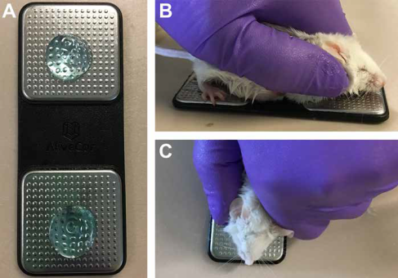

**Figure 1.** Use of smartphone ECG device in mice. (A) Smartphone ECG device prepared with ultrasound gel. (B) Side and (C) top views of a mouse positioned on the smartphone ECG device for recording of ECGs.

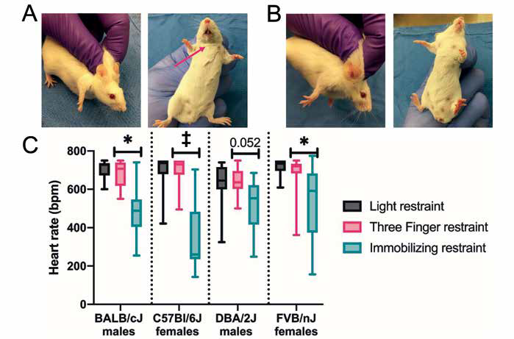

**Figure 3.** Immobilizing restraint but not 3-finger restraint induces bradycardia in 4 strains and both sexes of mice. (A) Standard immobilizing restraint as characterized by a dorsal longitudinal skin fold, a crease on the ventral neck (arrow), and forelimbs abducted dorsally. (B) Three-finger restraint as characterized by a dorsal transverse skin fold, absence of crease on the ventral neck, and forelimbs in a natural position. (C) Heart rates measured by smartphone ECG for 3 handling methods (light minimal restraint, 3-finger restraint, and standard immobilizing restraint) in 4 strains of mice, both sexes, and 3 handlers. Data is presented as box and whisker plots with the whiskers representing minimum and maximum, the box the upper and lower quartiles, and the middle line the median, n = 10 (BALB/cJ); 9 (C57BL/6J), 5 (DBA/2J); and 15 (FVB/nJ). * P < 0.05, ‡ P < 0.001, Tukey HSD posthoc test between 3-finger and immobilizing restraints.

QUESTIONS

1. T/F: SP-ECG devices have been validated in several species.

2. T/F: The SP-ECG device does not require ultrasound gel in species other than mice.

3. Which of the following applies to the use of this SP-ECG device:

a. Ideal for surgical monitoring in mice

b. Frequent sensor manipulation

c. Minimum 20 seconds needed to save recording

d. Surgical device implantation

e. Limited resolution

ANSWERS

1. True

2. True

3. e (a. HR inaccurate at normal mouse rate must manually calculate, b. Frequent app and mouse manipulations but not sensors, c. Min 10 secs, d. non-invasive)

**Rowley et al. Comparison of Two Hair Removal Methods in Sprague-Dawley Rats (*Rattus norvegicus*), pp. 213-220**

Domain 1

Primary Species: Rat (*Rattus norvegicus*)

SUMMARY

Introduction: One purpose of aseptic technique in rodent surgery is to reduce or eliminate the bacterial load on the animal prior to the start of surgery to prevent the introduction of bacteria into the sterile surface below the skin. Insufficient or inappropriate skin preparation may result in surgical site infections (SSI) and SSI can delay, or compromise wound healing.

Hair removal also facilitates visibility of the surgery site and removes a potential foreign-body that may result in SSI. The 3 most common hair removal methods are shaving with a razor, clipping the hair with an electric razor, and using a depilatory agent.

In human patients, recommendations are that the hair not be removed unless visualization is needed, or the hair would interfere with the surgical site or postsurgical bandaging. Because using a razor has been shown to traumatize the skin, resulting in higher rates of SSI. Even though depilatory agent is a better method, it can cause transitory lymphocytic reaction, and some individuals may have a sensitivity reaction.

In mice, hair removal with either clipping or depilatory agent resulted in acceptable healing. But, in rat, no studies have compared the effects of clipping and a depilatory agent on the prevalence of SSI and on wound healing in rats.

This study hypothesizes that using a depilatory agent as a hair removal method in rats will reduce bacterial counts, dermal trauma, and SSI as compared with using clippers.

Results and Discussion: The results of this study demonstrate that either method of hair removal is appropriate, with no differential effect on the development of SSI and satisfactory healing by Day 10.

The depilatory agent developed a mild to moderate sensitivity reaction (small nonerythemic bumps and petechiae of the skin), but this can be prevented by clipping the hair prior to using the depilatory agent to decrease contact time and decrease sensitivity reactions. Also, using a soft gauze with a higher weave may protect the skin better.

Even though it’s not significant and not relevant clinically, the bacterial load of the depilatory-treated rats remained higher than the clipper treated rats (Staphylococcus spp. and Aerococcus spp.). So, this data indicate that a depilatory agent should not be considered to reduce bacterial load.

the ASEPSIS grading system include histology analysis (inflammation, fibrosis, infection, follicular change) and it is often the ’gold standard‘ for identifying infected wounds and for describing delayed wound healing (lower score=satisfactory healing)

QUESTION (True or False)

1. The clipping and depilatory methods are safe and effective hair removal methods resulted in satisfactory healing of a biopsy site without dermal surgical site infections.

ANSWER

* 1. True

**Feldman et al. Effects of Cisapride, Buprenorphine, and Their Combination on Gastrointestinal Transit in New Zealand White Rabbits, pp. 221-228**

Domain 1  
Primary Species: Rabbit (*Oryctolagus cuniculus*)

SUMMARY:Buprenorphine is a partial μ-opioid receptor agonist that has been shown to prolong gastrointestinal (GI) transit times and reduce fecal output and food/water consumption in male rabbits. This increases the risk of GI stasis (i.e. decreased muscular contractions of the stomach and intestines), which can cause blockage and proliferation of harmful bacteria. Clinical signs include reduced appetite, small or no fecal pellets, and abdominal discomfort. The current standard of care for GI stasis includes forced feedings, correcting dehydration, and promoting GI motility. Cisapride is a serotonin 5-hydroxytryptamine 4 receptor agonist that is prokinetic and has been used in other species to increase GI motility. The goals of this paper were to 1.) characterize the GI motility effects of buprenorphine in female rabbits, and 2.) evaluate the efficacy of cisapride in rabbits and its ability to ameliorate the negative GI side effects of buprenorphine.

Healthy, intact, female New Zealand White rabbits were divided into the following treatment groups: 1.) control, 2.)  buprenorphine, 3.) cisapride, and 4.) cisapride and buprenorphine. All treatments were administered every 8 hours for 48 hours. The rabbits were anesthetized, and barium-filled spheres were administered by orogastric tube prior to the first treatment in order to measure GI transit time. Fecal output, food and water consumption, and body weight were also measured.

GI transit time was significantly longer in rabbits who received buprenorphine, regardless of concurrent treatment with cisapride. Buprenorphine treatment was also associated with decreased fecal output and food/water consumption. Cisapride did not have any effect on GI transit time, fecal output, or food/water consumption. Body weight did not differ between the treatment groups.

QUESTIONS

1. Which of the following is (are) risk factors for the development of GI stasis in rabbits?

a. Stress

b. Inappropriate diet

c. GI blockage

d. All of the above

2. Which of the following is a muscular structure in the colon that regulates the elimination of hard vs. soft pellets?

a. Colonic haustra

b. Fusus coli

c. Sacculus rotundus

d. Vermiform appendix

3. Rabbit feces consists of hard and soft pellets. Which pellet type comprises the majority of fecal output?

a. Hard pellets

b. Soft pellets

c. Equal amounts of hard and soft pellets

ANSWERS

1. d. All of the above

2. b. Fusus coli

3. a. Hard pellets

**Yolles and Lee-Stubbs. Comparison of Direct and Indirect Methods of Measuring Arterial Blood Pressure in Healthy, Anesthetized African Green Monkeys (*Chlorocebus aethiops*), pp. 229-237**

Domain 2: Management of Pain and Distress

Tertiary Species: Other Nonhuman Primates

SUMMARY: Quantitative blood pressure (BP) management is critical for assessing cardiovascular health, monitoring physiological status under anesthesia and making clinical decisions. A mean arterial pressure less than 60 mmHg in most mammalian species can lead to hypo perfusion resulting in renal failure and shock.   Direct blood pressure measurement through an arterial catheter is the gold standard, but is invasive, technically challenging and requires sedation.  Indirect blood pressure monitoring include oscillometry, high-definition oscillometry and Doppler flow.  Guidelines developed by the American College of Veterinary Internal Medicine state that blood pressure should be measured using devices validated in the species of interest.  Since methods of indirect BP in African Green Monkeys (AGM) have not been validated, this study was undertaken to do so.  Ultrasonic Doppler flow and oscillometric BP measurements were compared to direct BP measurements in 8 healthy, anesthetized AGMs. For a BP system to be validated, the mean difference for systolic and diastolic pressures is +/- 10 mm Hg or less with a standard deviation of 15 mm Hg or less when compared to direct BP. In this study, indirect BP measured by either Doppler or oscillometry showed poor correlation to direct SP for systolic, diastolic and mean arterial pressure.  Indirect BP generally underestimated direct BP, systolic BP, diastolic BP and mean arterial pressure among all 8 subjects and did not meet the requirements for validation.

QUESTIONS

1.   Name the genus/species of African Green Monkeys.

2.  AGMs are an animal model for:

a. Diabetes

b.  AIDS

c.  Infectious diseases

d.   All of the above

3.  Which entity has developed guidance for validating blood pressure monitoring devices?

a.   ACLAM

b.  ASR

c.  ACVIM

d.  AVMA

4.  T/F:  Doppler and oscillometric devices can provide accurate BP readings in AGMs.

5.  Name two reasons why direct BP measurement is a challenge.

ANSWERS

1.  *Chlorocebus aethiops*

2.   d

3.  c

4.  False

5.   The procedure can be technically challenging and generally requires sedation in primates.