**Journal of the American Association for Laboratory Animal Science**

Volume 57, Number 1, January 2018

**OVERVIEW**

**Chatigny et al. Updated Review of Fish Analgesia, pp. 5-12**

Domain 1 (T4), 2 (T2) & 3 (T2)

SUMMARY: Fish are second largest group of all animals used in research closely followed by mice (Canadian Council for Animal Care). Similar to other research animals, fish frequently undergo potentially painful surgical procedure. However, unlike in other animals (e.g., mice), analgesics use in fish are limited. Currently, fish are generally anesthetized without analgesia for painful surgical procedures. This is in part due to the controversial believe that lower vertebrates such as fish experience less or no pain. Furthermore, a systematic validated approach to assess pain in fish is also lacking. In this review paper, authors summarized the recent research updates in fish analgesia and provided information on drug and dose of different analgesics use for clinicians or researcher. The main agents that have been investigated show analgesic effects in fish are opioids (buprenorphine, butorphanol, morphine and tramadol), NSAID (aspirin, carprofen, flunixin, ibuprofen, ketoprofen, ketorolac), and local anesthetics (lidocaine), primarily in rainbow trout and zebrafish. The following table summarized different analgesics doses used, beneficial and side effects in various species of fish.

|  |  |  |  |  |  |
| --- | --- | --- | --- | --- | --- |
| Agent(schedule) | Dose | Species(route) | Side effects | Beneficial effects | Refs |
| Opioids |  |  |  |  |  |
| Buprenorphine (III) | 5μM, 0.005–0.2 μg/mL | Zebrafish (W) | Hyperactivity | Reversed thermal aversion Ameliorated behavioral changes | 22, 74 |
|  | 0.01–0.1 mg/kg | Rainbow trout (IM, SC) | Depressed activity at 1 mg/kg | Ameliorated ventilation and heart rates | 29, 49 |
| Butorphanol (IV) | 0.4 and 10 mg/kg | Carp (IM) | Decreased ventilation rate and buoyancy problems | Mild behavior-sparing effect Improved food consumption | 4, 33 |
|  | 0.25-5 mg/kg | Chain dogfish (IM) | — | — | 23 |
|  | 0.1-0.4 mg/kg | Goldfish (IM) | — | — | 76 |
|  | 0.2 and 0.5 mg/L | Zebrafish(W) | — | — | 65 |
| Morphine (II) | 10–50 mg/kg and 0.12–48 mg/L | Goldfish (IM, W) | Hyperactivity | MAC reduction Ameliorated pain related behaviors | 35, 55, 57, 76 |
|  | 40 and 300 mg/kg | Rainbow trout (IM, IP) | — | ED50 = 6.7 Ameliorated pain related behaviors and ventilation | 52, 70, 72 |
|  | 17 mg/kg IV and 40 mg/kg IP | Winter flounder (IP, IV) | Bradycardia followed by a prolonged increase in car­diac output and heart rate | Blocked cardiovascular response to a noxious stimulus | 51 |
|  | 3 and 6 mg/kg and 1, 2, and 48 mg/L | Zebrafish (IM, W) | Hyperactivity | Possible anxiolytic effect Ameliorated activity | 20, 45, 46, 80 |
|  | 300 mg/kg | Atlantic salmon (IM, IP) | — | Possible anxiolytic effect | 56 |
|  | 5 and 20 mg/kg | Carp (IM, IP) | Hyperactivity | Ameliorated ventilation and food consumption Anti-inflammatory effects | 4, 12 |
| Tramadol (IV) | 10–100 nmol/g | Carp (IM) | — | Increased nociceptive threshold | 16 |
|  | 10 mg/fish | Zebrafish (IM) | Hyperactivity and surface respiration | — | 82 |
| NSAID |  |  |  |  |  |
| Aspirin (OTC) | 1 and 2.5 mg/L | Zebrafish (W) | — | Ameliorated activity and ventilation | 45, 46, 65 |
| Carprofen (Vet) | 1–5 mg/kg | Rainbow trout (IM) | Depressed activity at 5 mg/kg | — | 49 |
| Flunixin (Vet) | 0.5 mg/kg | Rainbow trout (IM) | — | — | 63 |
|  | 8 and 20 mg/L | Zebrafish (W) | — | — | 45, 46 |
| Ibuprofen (OTC) | 5–470 mg/L | Fathead minnows (W) | — | Anti-inflammatory effects | 59 |
|  | 400 μM | Zebrafish (W) | — | — | 22 |
| Ketoprofen (Rx) | 2 mg/kg | Carp (IM) | — | Reduced postsurgical muscle damage | 33 |
|  | 1–4 mg/kg | Chain dogfish (IM) | — | — | 23 |
|  | 0.5–2 mg/kg | Goldfish (IM) | — | MAC reduction | 76 |
|  | 2 mg/kg | Rainbow trout (IM) | — | — | 60 |
| Ketorolac (Rx) | 0.5 mg/kg | Rainbow trout (IM) | — | — | 63 |
| Local anesthetics |  |  |  |  |  |
| Lidocaine (Rx) | 4.5–18 mg/kg | Rainbow trout (SC) | — | — | 49 |
|  | 1–5 mg/L | Zebrafish (W) | — | Ameliorated activity and ventilation | 45, 46, 65 |
| Others |  |  |  |  |  |
| Medetomidine (Vet) | 0.01–0.025 mg/kg | Goldfish (IM) | — | MAC reduction | 76 |
| |  | | --- | | —, no pertinent information reported; MAC, minimum anesthetic concentration; Nd, no data; OTC, over the counter; Rx, not restricted but prescription required; vet, for veterinary use only; W, in the ambient water | | Schedule information is provided for restricted drugs. Binomial nomenclature for fishes is given in the text at their first mention. The frequency of administration is not mentioned because repeated administration of analgesic drugs has not yet been investigated | | | | | | |

Among opioid, morphine is the most studied analgesic and the drug that has shown the most beneficial effects in fish although some paradoxical hyper activity in fish has been reported at low doses. Morphine has shown to be anti-inflammatory, anxiolytic and reduced various behaviors that are associated with pain, decreased minimum anesthetic concentration (MAC) of general anesthesia MS222 (tricaine methanesulfonate) needed to prevent a response to a noxious stimulation. Morphine is one of the few analgesics (others meloxicam and tramadol) for which pharmacokinetic information for fish is available. Morphine is eliminated much more slowly in fish than mammals, and there is a marked interspecies variation (e.g., rainbow trout eliminated morphine significantly faster than winter flounder. Morphine uptake in goldfish was very slow when administered in the water, therefore injection appeared to be a more appropriate administration route. In addition, various anxiogenic effects were reported even after morphine was withdrawn after a week of chronic administration. Morphine effects can be inhibited by naloxone. Other Opioids such as butorphanol, buprenorphine, tramadol and dermorphine (a natural hepta-peptide opioid that acts as an agonist with high potency and selectivity to mu Opioid receptors) are shown to have analgesic effects in fish.

Till date, there are 7 non-steroidal anti-inflammatory drugs (NSAID) have been tested in fish. These include ketoprofen, meloxicam, ibuprofen, carprofen, flunixin, ketorolac, and aspirin. At the doses tested, NSAID have not yet proven to be particularly beneficial to fish, however, no adverse side effects have not been reported and are appearing to be safe in fish.

Local anesthetics such as lidocaine and Novocain have been shown to have analgesic effects in fish. It is of noteworthy that tricaine methanesulfonate, which is regularly used to produce and maintain general anesthesia in fish, is a local anesthetic. Local anesthetics can produce analgesic effects by acting locally at the skin or centrally by absorbing through gills.

Pain Assessment in Fish: There are currently no well validated and generally accepted parameters to assess pain in fish are available. The physiologic and behavioral parameters used to assess pain in other animals are not easily translated to fish. In some instances, normal physiological values or behavior are not known or impractical to measure. Also, there is a wide range of species differences in fish. Because of these reasons authors expressed doubts on whether existing literature suggesting analgesic effects of drugs in fish. The commonly used parameter in other animals, cortisol levels, is not a very sensitive indication of pain in fish. In addition, feeding rate has been found to be an unreliable parameter in some species of fish. However, opercular rate and fish weight have been proved to be more reliable indicator of pain in fish. Thus, it necessary for future research to develop validated behavioral and physiologic parameters to assess pain and nociception in fish.

Although authors expressed concerns on the efficacy of the analgesics but of the opinion that their use is beneficial in fish and are considered safe. Authors also expressed caution when extrapolating the dose of an analgesic from one species of fish to another because of pharmakinetic and physiological differences between species. Use of analgesics in fish certainly improve fish welfare. Researcher are advised to make educated decisions that are based on the available literature and whether use analgesics interfere with experimental parameters.

QUESTIONS

1. T/F. According to the latest animal data report from the Canadian Council for Animal Care, fish are currently the largest group of all animals used in research, closely followed by mice.

2. T/F. TRICAINE-S (MS-222 or tricaine methanesulfonate) is the only FDA approved fish anesthetic for field anesthesia.

3. What is withdrawal period of MS-222?

a. 10 days

b. 18 days

c. 21 days

d. 30 days

ANSWERS

1. True

2. True

3. c

**ORIGINAL RESEARCH**

***Biology***

**de Souza et al. Standard Electrocardiographic Data from Capuchin Monkeys (*Cebus apella*, Linnaeus, 1758), pp. 13-17**

Domain 1: Management of Spontaneous and Experimentally Induced Diseases and Condition

Tertiary Species: Other Nonhuman Primates

SUMMARY: Capuchins are a commonly used model of Chagas disease, which induces myocardial fibrosis and thus electrocardiographic changes. The authors describe the electrocardiographic tracings from 12 healthy capuchin monkeys (*Cebus apella*) restrained with a combination of ketamine/midazolam. Animals were included in the study based on overall health status and were excluded based on systemic disease, cardiovascular abnormalities evident on physical exam, and abnormal response to handling. The mean age of animals was 3 years. The average anesthetic time for the recording was approximately 40 minutes. Animals were placed in right lateral recumbency and a digital veterinary electrocardiograph with 10 derivations was used to record heart rate, duration and amplitude of the P wave, PR interval, QRS complex, R wave, ST segment, QT interval (and corrected QT interval) and T-wave.

There was a correlation between QT interval and age, particularly for females, but none of the other parameters were different between males and females and all animals had a normal sinus rhythm. Heart rates were within normal range for the species. There were several differences in P wave duration and QRS complex in animals in other studies using different anesthetic protocols.

QUESTIONS

1.  Which of the following species is highly susceptible to hypertrophic cardiomyopathy?

a.  *Mustela putorius furio*

b.  *Aotus spp.*

c.  *Saimiri sciureus*

d. *Macaca mulatta*

2.   Which of the following nonhuman primate species is predisposed to cardiac diseases resulting in contractility deficits and decreased ejection fraction?

a.  *Aotus spp.*

b.  *Cebus paella*

c.   *Samiri sciureus*

d. *Macaca radiata*

3.  Which of the following parameters in clinically important in toxicity studies?

a.   T wave polarity

b.  QRS amplitude

c.  QT interval

d.  P wave amplitude

ANSWERS

1.   b. *Aotus spp.*

2.  c. *Samiri sciureus*

3.  c. QT interval

***Husbandry***

**Eichner et al. Effects of Intracage Ammonia on Markers of Pulmonary Endothelial Integrity in Mice Housed in Static Microisolation Cages, pp. 18-23**

Domain 1: Management of spontaneous and experimentally induced diseases and conditions

Task 1: Prevent spontaneous or unintended disease or condition

Primary Species: Mouse (*Mus musculus*)

SUMMARY: The purpose of the study was to evaluate the influence of naturally occurring intracage ammonia on the health of the lower pulmonary tract in mice and to evaluate whether static microisolation caging is appropriate for maintenance of mice before initiation of acute lung injury (ALI) studies. The group performed several assays commonly used in mouse ALI studies to evaluate the effects of exposure to cyclical, naturally occurring ammonia levels on pulmonary integrity and inflammation. C57BL/6 animals were housed in static microisolation or open-top cages. The ammonia levels in the cages were measured and showed an increase beginning at day 3 for the microisolation cages peaking (141.3 ppm) at day 7 (cage change-out). Ammonia levels in the open-top cages never exceeded 5 ppm. The group employed the following testing to determine effects on the lung to ammonia: bronchoalveolar lavage (BAL) cell counts and protein concentration, excess lung water content (ELW), Evans blue permeability assay (EBA), lung tissue myeloperoxidase assay (MPO) and lung histopathology. Neither BAL cell counts, protein concentration, ELW, EBA, nor MPO differed significantly between groups. Lung histopathology showed minimal, incidental changes in all mice. These results illustrate the fact that exposure to ammonia levels observed in this study do not negatively influence murine models of ALI during the prestudy period.

QUESTIONS

1.  What changes characterize acute lung injury?

2.   What are the primary cellular constituents of BAL demonstrating inflammation within the lung airspaces?

3.  T or F. Reduced levels of macroenvironmental humidity results in reduced generation of ammonia.

ANSWERS

1.  Microvascular endothelial injury leading to increased capillary permeability, transepithelial neutrophil migration and a shift of protein-rich fluid into the interstitium

2.  Macrophages, lymphocytes and neutrophils

3.  True

***Management***

**Lieberman et al. Evaluation of 6 Methods for Aerobic Bacterial Sanitization of Smartphones, pp. 24-29**

Domain 4: Animal Care; K3. Methods of sterilization, sanitation, and decontamination

SUMMARY: This study evaluated the efficacy of UV smartphone sanitizing devices vs liquid methods of sanitization.

Background: Smartphones have increased in use and popularity, even in laboratory-animal specific applications, such as electronic medical records, animal census tools, and veterinary pharmaceutical formularies. It is known that these devices can harbor bacterial nosocomial pathogens, including methicillin-resistant *Staphylococcus aureus*, *Acinetobacter baumannii*, *Pseudomonas aeruginosa*, *Escherichia coli*, *Klebsiella*spp., *Enterobacter*spp., enterococci, and streptococci, among others. Therefore, smartphones have the potential to serve as fomites, specifically in the lab animals setting (e.g. inside vivaria or procedure rooms). This risk is especially critical when maintaining SPF genetically modified, immunodeficient, and humanized mouse models.

Methods: Sampled three separate areas on a variety of smartphones (face, junction, and case) before and after sanitization and inoculated plates to assess aerobic colony growth. Sanitization methods included 2 commercially available smartphone UVC-sanitizing devices (PS300, PhoneSoap; FBM120, Flashbox mini), 70% ethanol spray, 0.55% sodium hypochlorite wipes, quaternary ammonium disinfectant spray, and cleaning with a delicate-task wipe (KimWipe).

Findings:

* Smartphone faces had significantly fewer colonies than at the junction of the smartphone and case.
* No differences in colony number with or without a screen.
* Case type (hard plastic, hard plastic-hard silicone, and hard silicone did not differ in colony number.
* The FBM120 device had a higher reduction in colony count than all methods except the PS300.
* The delicate-task wipe was effective at reducing bacterial burden by 55% to 70%.
* PS300 was better than quaternary ammonium disinfectant and delicate-task wipes.
* The FMBM120 and PS300 devices showed the most consistent percentage reduction in colony count.
* All 7 smartphones sanitized with the FBM120 demonstrated 100% reduction in aerobic bacterial colonies at all 3 sampling sites after sanitization.

Conclusion: To encourage compliance, sanitization methods should work rapidly and not damage mobile devices. Because of the risks of smartphone damage with exposure to liquid disinfectants, UVC sanitization methods are potentially superior to disinfection with bleach, ethanol, or quaternary ammonium solutions. Between the 2 commercially available 254-nm UVC devices evaluated in this study, the FBM120 was more consistent in reducing the bacterial burden and required only a 2-min sanitizing period. UVC kills cells through the induction of pyrimidine dimers in DNA, disrupting the DNA replication process. The effectiveness of UVC sterilization is dependent on the dose, which is defined as the amount of UV energy (mJ) per unit area (cm2) and sometimes expressed as irradiance (J/s/cm2 or W/cm2). Doses of 15 mJ/cm2 are able to achieve 3-log to 4-log reductions in *Klebsiella pneumoniae*, *Citrobacter*spp., *Escherichia coli*, *Salmonella typhi*, *Shigella sonnei*, *Staphylococcus aureus*, and *Enterococcus*(*Streptococcus*) *faecalis*; however, higher doses are required for rotavirus and poliovirus (>30 mJ/cm2) and *Bacillus subtilis*spores (>60 mJ/cm2). Appropriate biosecurity protocols must be established to prevent fomite transmission of bacterial pathogens.

QUESTIONS

1. Based on the Guide, what are the definitions for sanitation (a), cleaning (b), and disinfection (c)?
2. What is the mechanism for UVC cytotoxicity?

ANSWERS

1. (a) Sanitation – the maintenance of environmental conditions conducive to health and well-being – involves bedding change (as appropriate), cleaning, and disinfection. (b) Cleaning – removes excessive amounts of excrement, dirt, and debris. (c) Disinfection – reduces or eliminates unacceptable concentrations of microorganisms.
2. Pyrimidine dimer formation in DNA, disrupting DNA replication

***Experimental Use***

**Dudley and Boivin. Evaluation of a Commercially Available Euthanasia Solution as a Voluntarily Ingested Euthanasia Agent in Laboratory Mice, pp. 30-34**

Domain 3: Research

Primary Species: Mouse (*Mus musculus*)

SUMMARY: The purpose of this study was to identify 1) a highly palatable drug delivery vehicle for oral administration, and 2) the efficacy of voluntary oral administration of a euthanasia solution. The authors hypothesized that the voluntary ingestion a lethal dose of the euthanasia solution would result in sedation followed by a loss of unconsciousness and death. 4 groups of ten mixed sex, C57Bl/6 mice were given Pillsbury cookie dough with or without flavor enhancers (peanut butter powder, berry-flavored gelatin and bacon crumbles) and the amount consumed after 1 hour was measured. As the cookie dough with or without flavor enhancers were deemed highly palatable, researchers proceeded to answer their second question. Cookie dough with Euthasol (pentobarbital-phenytoin) mixtures contained an approximately 200 mg/kg dose of pentobarbital for an average mouse per bolus offered. There were 10 experimental groups (total, 140 mice): 4 groups of single-housed, 4 groups of pair-housed, 1 group tested 30 minutes after the onset of dark phase and 1 group tested after a 16 hour fast. Mice were observed for 1 hour after the bolus was placed in the cage for signs of lethargy, ataxia, recumbency and death. Following which the remaining uneaten bolus was removed, weighed, and the actual ingested dose of Pentobarbital was calculated. All flavors of cookie dough were very well accepted with 82%-94% consumed within the hour. Palatability sharply declined with the addition of Euthasol, and most mice consumed a dose far lower than the intended 200 mg/kg. The groups fed in the dark phase or after fasting consumed larger doses of the pentobarbital. In any group, the few mice that ingested the majority of the offered bolus either became ataxic or had no clinically observable signs. No mouse ingesting any amount of the bolus lost their righting reflexes, became unconscious or died. Over all, this study found that voluntary oral administration of Euthasol mixed with cookie dough is not an effective means of euthanasia for mice.

QUESTIONS

1.  T/F: Phenytoin alone is typically used in veterinary medicine as a euthanasia agent.

2.   In which of the following situations is compounding allowed?

a.  Approved drugs compounded for extralabel use

b.  Compounding from active pharmaceutical agents (bulk drugs)

c.  Both of these are allowed

d.   Neither of these are allowed

ANSWERS

1. False – Phenytoin is used clinically as an anticonvulsant agent.

2.  a. Approved drugs compounded for extralabel use – according to The Animal Medicinal Drug Use Clarification Act, extralabel drug use is permitted under specific conditions.

(<https://www.fda.gov/AnimalVeterinary/GuidanceComplianceEnforcement/ActsRulesRegulations/ucm085377.htm>)

**Gehling et al. Evaluation of Volume of Intramuscular Injection into the Caudal Thigh Muscles of Female and Male BALB/c Mice (*Mus musculus*), pp. 35-43**

**Domain 3: Research; K1.** Biomethodology techniques (e.g., collection of blood and other body fluids and tissues; handling and restraint; administration of compounds and treatments)

**Primary Species:** Mouse (*Mus musculus*)

SUMMARY: The most common route for intramuscular (IM) injection in mice is the thigh muscle (distal to gluteal muscles and proximal to stifle). Current volume recommendations for IM injections in mice range from 1.5 to 100 µL for a 30-gram mouse. Studies in rats demonstrated that the rate of absorption after IM injection is profoundly affected by volume, with both smaller and larger volumes causing a delay in absorption. BALB/c mice in this study were injected with iohexol (240 mg/mL), a CT contrast agent in range of volumes (25, 50, 100, 200 µL) using a Hamilton syringe. The mice were then imaged with CT @ 10, 20, 30,45,60, 90, 120, 150, and 180 minutes after iohexol administration.

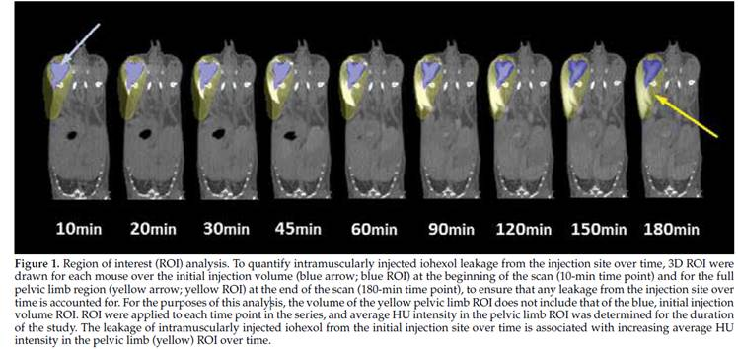

**Results:** In this study, 100 and 200 µL volume groups had a portion of the iohexol persist in the tissue for 180 minutes. As intramuscular injection volume increased, distribution of the injectate outside of the target tissue also increased.

The findings of this study suggest that the optimal volume for intramuscular injection of mice is 50 µL or less. As injection volume increased, extramuscular distribution increased. In a true intramuscular injection, the needle is advanced in the belly of the muscle. A common side effect of IM injection is retrograde leakage, backflow, or injectate along the needle track. The primary mechanism of absorption of injectate from muscle is vascular blood flow through the muscle belly perimysium. In intermuscular injection, the needle is advanced between the collection of muscle fibers that are surrounded by epimysium. In intermuscular injection, absorption is primarily through the lymphatic system. Absorption is faster through intramuscular injection rather than intermuscular injection.

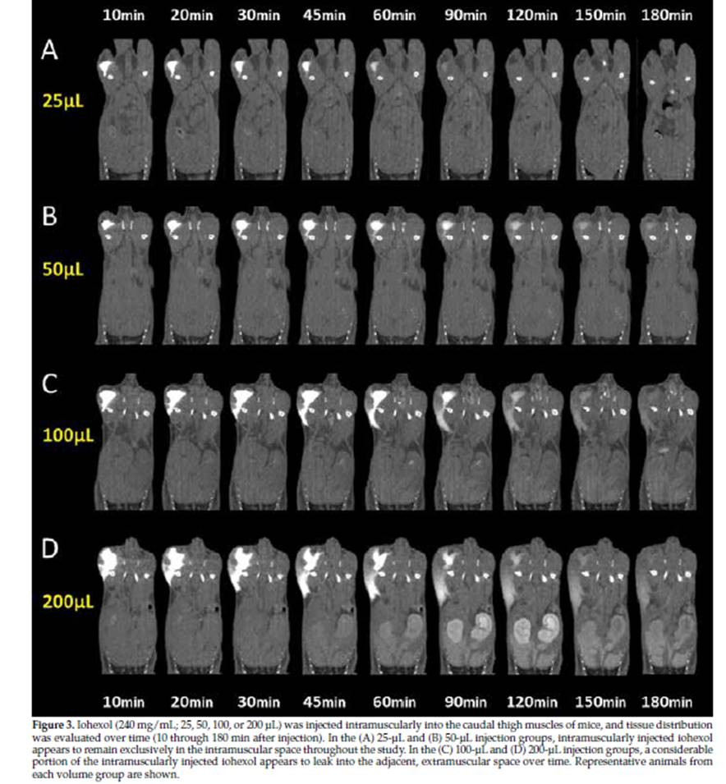

**QUESTIONS**

1. According to this study, what is the optimal volume for intramuscular injection of mice?

a. 100 µl

b.   >150 µl

c.  < 50 µl

d.  200 µl

e.  <250 µl

2.  What is a common anatomical location for intramuscular injections in mice?

a. Spinotrapezius

b. Biceps brachii

c.  Latissimus dorsi

d.  Caudal thigh muscles

e.  Cranial shoulder muscles

ANSWERS

* 1. c
  2. d

**Morley et al. Accuracy of 5 Point-of-Care Glucometers in C57BL/6J Mice, pp. 44-50**

SUMMARY: The purpose of the study was to determine the accuracy of 5 point of care glucometers (POCG) (1 veterinary and 4 human) in determining the blood glucose concentrations in female C57BL/6 mice and to determine whether whole blood, plasma or serum was the most appropriate sample type for each glucometer. Serum samples were tested on the biochemical analyzer and the whole blood, serum and plasma on the 5 POCG (AlphaTRAK2, Contour Next, Freestyle Precision Neo, OneTouch Ultra2 and Accu-Chek Aviva). The results demonstrated that any of the 4 human POCG would be appropriate choices when measuring blood glucose concentrations in whole blood samples from female C57BL/6, whereas, the veterinary POCG is not. The results also indicate that when serum or plasma is used, Contour Next or Accu-Chek would be better choices than the other POCGs. Hence, the authors recommend validation of POCG against a reference method if using serum or plasma sample is necessary.

QUESTIONS

1.  POCG and biochemical analyzers work by using chemical enzymatic reactions including those mediated by -----

2.  PCV values in mice range from

ANSWERS

1. Hexokinase, glucose oxidase and glucose dehydrogenase

2.35-55%

**Hoffman et al. Hydrophobic Sand Versus Metabolic Cages: A Comparison of Urine Collection Methods for Rats (*Rattus norvegicus*), pp. 51-57**

Domain: 3

Primary Species: Rat (*Rattus norvegicus*)

SUMMARY: Traditionally, urine collection from rodents occurs via use of metabolic cages, where animals would be single housed for a period of 16 to 24 hours. Hydrophobic sand has recently emerged as a new method for collecting urine. Hydrophobic sand is a biodegradable material with a nontoxic urine-repelling coating, which could replace the bedding in a normal cage. The authors of this paper hypothesized that markers of stress during urine collection (weight loss, fecal pellet output, corticosterone levels) would be significantly less than those collected by using metabolic cages. They also hypothesized that using the sand would not introduce deleterious contaminants that would alter clinically relevant urine marker measurements. This study involved 8 rats in a within-subjects crossover design, where differences in stress markers, urinary markers, and urine volume of clinically healthy male Sprague-Dawley rats during 2, 4, and 6-hour collection sessions in hydrophobic sand and metabolic cages were measured. Results showed no differences in urine refractive index, urine specific gravity, or any of the common urinalysis clinical markers. The total volume of urine collected in metabolic cages and hydrophobic sand did not differ significantly by the end of the 2-h sessions, or the second 6-h session, but was greater in the metabolic cages by the end of the 4-h sessions and the first and third 6-h session. There were no differences in stress markers, including urine corticosterone, between the two groups. Observed behavior suggested rats were more comfortable in the cages containing the hydrophobic sand than the metabolic cages. The authors concluded that the hydrophobic sand was no more stressful for the rats than the metabolic cages and may in fact be less stressful based off of observed behavioral differences. It was hypothesized that less urine was collected from the hydrophobic sand cages due, in part, to rats drinking the urine. Additionally, a majority of the urine was collected in the first 2 hours of the session, and the hydrophobic sand allowed for the periodic collection of samples.

QUESTIONS

1. Where is corticosterone produced in rats?

a. Adrenal gland

b. Anterior pituitary

c. Posterior pituitary

d. Pineal gland

e. Pancreas

2. According to this study, why was it thought that less urine was collected from the hydrophobic sand as opposed to the metabolic chamber?

a. Rats were less inclined to urinate on the sand

b. The sand was absorbing some of the urine

c. Rats were drinking from the puddles of urine

d. The metabolic chamber was less stressful and thus encouraged more normal behavior

e. Less urine wasn't collected from the hydrophobic sand

ANSWERS

1. a
2. c

And here's a link for those interested in seeing the hydrophobic sand in action: <https://youtu.be/pPOIUrsLUYU>

**Wallace et al. Effectiveness of Rapid Cooling as a Method of Euthanasia for Young Zebrafish (*Danio rerio*), pp. 58-63**

Secondary Species: Zebrafish (*Danio rerio*)

SUMMARY:There is a dearth of information reported on appropriate means of euthanizing fish embryos. Rapid cooling has been indicated as appropriate for adult zebrafish, but information on using this form of euthanasia for zebrafish under 6 months of age is not available. To investigate the appropriateness of the use of rapid cooling on juvenile zebrafish the authors bred and harvested 1221 viable embryos for use in the study. Groups of n=12 to n=40 at 3, 4, 7, 14, 16, 19, 21, 28, 60 and 90 days post fertilization (dpf) were placed into an ice water bath (0 to 4⁰ Celsius) for varying lengths of time (30s, 5, 10, 30, 45, and 60 min, 12 h). A mounted camera was put in place to capture loss of righting reflex and to monitor for behaviors associated with distress (piping, twitching and erratic swimming). Following exposure to the ice bath all fish were transferred to a recovery tank (26 to 28⁰ Celsius) and observed at time points of up to 24 hours. Results showed that fish younger than 14 dpf required up to 12 hours, fish aged 16 to 28 dpf required up to 5 minutes and fish greater than 28 dpf required 30s exposure to cold water for the rapid cooling euthanasia method to be effective.

QUESTIONS

1. At what age do zebrafish require an extended period of cold exposure (> 5 minutes) for rapid chilling to be an effective method of euthanasia?
2. At what larval age group was twitching observed during the rapid cooling process?
3. Were other signs of distress noted during rapid cooling?

ANSWERS

1. 14 dpf
2. 7 dpf, 25% of the cohort exhibited signs of twitching.
3. Yes, a small percent of fish 60 dpf and older exhibited piping (5 instances) and there was one instance of erratic swimming observed.

**France et al. Comparison of Direct and Indirect Methods of Measuring Arterial Blood Pressure in Healthy Male Rhesus Macaques (*Macaca mulatta*), pp. 64-69**

Primary Species: Macaques (*Macaca spp.*)

SUMMARY: Sixteen Indian-origin male Rhesus macaques ranging from 3-16 years old were sedated & anesthetized with 20 mg/kg ketamine and isoflurane. The study goals were to evaluate which method (indirect blood pressure) monitoring was most accurate compared with direct arterial catheterization (gold standard) and evaluate the accuracy of indirect BP at a given body location (lateral or dorsal recumbency). For indirect BP they used a single oscillometric device and ultrasonic Doppler; for direct BP they used 22 g arterial catheter was placed in the saphenous vessel. All blood pressures parameters were measured twice on the arm, leg and tail base and compared with the direct BP recordings. There was a significant difference between direct & indirect BP over time. Direct MAP (mean arterial pressure), SAP (systolic arterial pressure), DAP (diastolic arterial pressure) did not differ during oscillometric data collection. Indirect BP (doppler & oscillometry) were consistently lower than direct methods in all locations. The arm provided the best approximation SAP using Doppler. For oscillometry, the tail provided best SAP whereas the arm provided best MAP & DAP. Animal position did not affect SAP. Both MAP and DAP were increased in lateral recumbency (direct & oscillometric measurements). Oscillometry at the arm is the best indirect method for general BP readings in male rhesus macaques.

QUESTIONS

1. What is the best place to obtain blood pressure using an indirect method?

a. Arterial catheter

b. Arm

c.  Leg

d.  Tail base

2. What is considered the gold standard for measuring blood pressure?

a. Blood pressure cuff (oscillometry)

b.  Ultrasound

c.  Doppler

d.  Arterial catheterization

ANSWERS

1. b

2. d