Comparative Medicine
Volume 70, Number 2, April 2020

ORIGINAL RESEARCH

Hsi et al. Hypoglycemia after Bariatric Surgery in Mice and Optimal Dosage and Efficacy of Glucose Supplementation, pp. 112-119

Domain 1: Management of Spontaneous and Experimentally Induced Diseases and Conditions
Primary Species: Mouse (Mus musculus)

SUMMARY: Translational animal models of bariatric surgery are a vital tool for understanding the pathophysiologic mechanisms that occur postoperatively and the factors associated with surgical efficacy. For example, the Roux-en-Y Gastric Bypass (RYGB) mouse model is used for studying obesity and diabetes, however, there is an increase in post-operative complications as compared to the Vertical Sleeve Gastrectomy surgery.

Rodent surgical models may experience complications such as severe postoperative hypoglycemia, particularly given that blood glucose (BG) measurement and management are typically not included in routine rodent postoperative regimens. Glycemic management is imperative for optimal postoperative recovery in humans as well as animals. Both hyperglycemia and hypoglycemia can significantly influence rates of healing, morbidity, and mortality. Hypoglycemia, on the other hand, affects many physiologic functions ranging from metabolic to neurologic, all of which can have a significant impact on animal health, welfare, and study outcomes.

The overall objective of this study was to determine the frequency of hypoglycemia in C57BL/6N mice after RYGB surgery and evaluate the effect of dextrose supplementation on morbidity and mortality in postoperative hypoglycemic animals. Glucose pharmacokinetics in non-manipulated mice given 5% dextrose SQ or 50% dextrose oral–transmucosal (OTM) were characterized in order to determine the most appropriate minimally invasive route of administration for clinical treatment of hypoglycemia. The authors concluded that the SQ route consistently and reliably delivered glucose without causing significate adverse reactions.

A second aim of this study was to evaluate the frequency of hypoglycemic events after RYGB and the effects of SQ dextrose supplementation on morbidity and mortality. In order to achieve this, BG measurements and behavioral pain assessment (grimace test) was assessed. Hypoglycemic (BG ≤ 60 mg/dL) animals were assigned to dose (5% dextrose SQ) or no-dose treatment groups. 87% of the mice became hypoglycemic and no differences in grimace score nor mortality were reported.

In conclusion, results from this study show that hypoglycemia occurs frequently in mice following bariatric surgery and use of SQ dextrose can safely and effectively manage hypoglycemia events.

QUESTIONS
- The mouse grimace scale uses the following expressions to score for pain on a 3-point scale (0, not present; 1, moderate pain; and 2, severe pain): orbital tightening, nose bulge, cheek bulge, ear position, whisker change
- The Roux-en-Y Gastric Bypass mouse model is used for studying:
  - Obesity
  - Diabetes
  - a & b
- The C57BL/6N mouse is an ideal model to study effects of diet induced obesity when fed a 60% high fat ad lib for 4 weeks.

ANSWERS
- True
- c
- True

Meeker et al. Effect of Chronic Vitamin D Deficiency on the Development and Severity of DSS-Induced Colon Cancer in Smad3 -/- Mice, pp. 120-130

Domain 3
Primary Species: Mouse (Mus musculus)

SUMMARY: In humans, epidemiologic evidence suggests that low serum vitamin D increases the risk of developing IBD and colorectal cancer. The current study investigated a method for inducing chronic vitamin D deficiency in Smad3 ^{-/-} mice, prone to the development of colitis and colonic adenocarcinomas following treatment with DDS, for as long as 18 weeks without causing calcium imbalance. Smad^{-/-} or wild type mice were fed a diet with standard (1 IU), low (0.2 IU), or null (<0.02 IU) quantities of vitamin D. After 2 weeks on the diet, colitis was induced with 1.5% DSS in drinking water for 3 days. Serum vitamin D, calcium, phosphorous, bone mineral density, cecum, and colon histopathology, and BrdU incorporation were assessed.

Mice fed a low vitamin D diet did not have lower serum vitamin D or calcium than mice on a control diet. Mice fed a vitamin D-null diet had significantly lower serum vitamin D than mice fed a control diet, however, serum vitamin D levels rebounded within 3 weeks of being fed the low vitamin D diet and reached similar levels to mice fed a control diet. The vitamin D-null diet did not cause changes in serum calcium, phosphorous, bone density, or body weight. The severity and incidence of colonic disease was lower in mice fed the vitamin D-null diet compared with mice fed the control diet, including improved survival, lower incidence of invasive colon carcinoma, lower typhlocolitis scores, and decreased incidence of colonic dysplasia. Mice on the vitamin D-null diet had a higher incidence of epithelial cell proliferation, demonstrated by increased BrdU staining.

The results of this study indicate that feeding a vitamin D-null diet to Smad3^{-/-} mice causes significantly decreased serum vitamin D without impacting serum calcium, and that a low vitamin D diet is not sufficient to induce low serum vitamin D in this strain. Results also indicate that low serum vitamin D may be protective against DSS-induced colitis/dysplasia/neoplasia in this strain due to increased epithelial cell proliferation.

QUESTIONS
1. What signaling pathway is defective in Smad3^{tm1Par}/J mice?
a. PI3K-Akt
b. PI3K/AKT/mTOR pathway
c. Hippo
d. TGFβ
2. What is the biologically active form of vitamin D?
a. 25(OH)D
b. 1, 25-dihydroxyvitamin D
c. 7-dehydrocholesterol
d. Ergosterol
3. What is the primary function of BrdU staining
a. To label proliferating cells
b. To label collagen/fibrosis
c. To label polysaccharide polymers
d. To label lipids, triglycerides, and lipoproteins

ANSWERS
1. d
2. b
3. a

Brent et al. Influence of Genetic Background and Sex on Gene Expression in the Mouse (Mus musculus) Tail in a Model of Intervertebral Disc Injury, pp. 131-139

Domain 3: Research
Primary Species: Mouse (Mus musculus)

SUMMARY: This study was conducted to compare gene expression and histologic changes in response to a tail intervertebral (IVD) injury in the mouse tail. Both male and female mice on DBA and C57Bl/6 back grounds were studied. Specific genes that were examined included col1, col2 and adam8. Type 1 collagen (col1a1) and type II collagen (col2a1) change after injury and may represent repair and scar tissue formation. Adam8 belongs in the family of cell surface proteases which participate in remodeling of extracellular matrix, cell migration and processing of membrane-bound signaling molecules. To create the injury, under fluoroscopic guidance, the mouse coccygeal intervertebral discs were identified, and a 26-gauge needle was inserted into the IVD space until the needle tip breached 2/3 of the disc thickness. Gelatinous tissue was often found on the needle tip after its removal, suggesting that the needle puncture induces acute herniation of the gelatinous nucleus pulposus of the IVD. Both Co3-4 and Co5-6 were injured while Co4-5 and Co6-7 were used as controls. The animals were euthanized 1 week after tail injury. After analysis, the col1 expression was higher in DBA mice compared to C57Bl/6 mice but col2 expression was higher in C56Bl/6 mice than in DBA mice. This included injured and control. Adam8 expression was higher in DBA than C56Bl/6 mice only in injured mice. There was no difference in adam8 in control mice. When examining the influence of sex on gene expression, expression of col1 was not different between DBA and C57Bl/6 mice in either male or female mice whether injured or control. Expression of col2 did not differ between male and female DBA mice in either injured or control situations. However, expression of col2 was higher in male C57Bl/6 mice in both injured and control situations. Adam8 expression was not significantly different between male and female mice on both backgrounds, whether injured or control. Histological changes were examined after staining with Safranin O, Alcian blue, Picrosirius red and hematoxyalin and eosin. Lesions were examined by 3 independent readers and there was no statistically significant difference between male and female on either background. The authors concluded there are some strain and sex changes in gene expression in DBA and C57Bl/6 mice following mouse tail IVD injury. Researchers should determine the appropriate strain and gender for their study based on these observations.

QUESTIONS
Match the stain to the appropriate description.
1. Safranon O a. Stains collagen I and III
2. Alcian Blue b. Stains acid mucins of used in staining sections of the GI tract
3. Picrosirius Red c. Stains growth plate cartilage and articular cartilage
(proteoglycans, chondrocytes, and type II collagen)
4. Strain differences have been identified in which of the following animal models:
a. Dental fluorosis
b. Alcoholic sensitivity
c. LPS endotoxin sensitivity
d. All of the above
5. Animal models of intervertebral disc disease include:
a. Mice
b. Goats
c. Rabbits
d. Primates
e. All of the above

ANSWERS
1. c
2. b
3. a
4. d
5. e

Morita et al. Spontaneous Ocular Abnormalities in Sprague-Dawley Rats, pp. 140-144

Primary Species: Rat (Rattus norvegicus)

SUMMARY: This study was done to assess inhouse historical control data regarding ocular toxicities in nonclinical studies that are important for understanding normal variations in spontaneous ocular abnormalities in experimental animals.

In this study, two 6-years period historical data of spontaneous ocular abnormalities and difference in the incidence of ocular abnormalities between the 2 periods was assessed. Historical data of 4-7 weeks old Sprague-Dawley Rats used in toxicity studies in the facility were assessed and the typical pretreatment ophthalmologic examination done are (i) binocular indirect ophthalmoscope and (ii) slit lamp microscopy. Incidences and locations of corneal opacity, lenticular opacity, hyaloid artery, retinal folds, and all other ocular abnormalities was compared.

The first period was from 2004-2009 (first 6-y period [FP]) and second period 2010-2015 (second 6-y period [SP]). The historical control data gathered was from 2033 male and 1322 female rats.

Result: The most common abnormalities seen were opacities in the cornea and lens and the incidence of lenticular opacity and persistent hyaloid artery differed significantly between male and female rats, with male being the higher ,and all other ocular abnormalities occurred at lower incidences. in both male and female rats, Corneal opacities were both localized in nasal and paracentral areas and lenticular opacities predominantly in nuclear area. In addition, comparison of spontaneous ocular abnormalities between FP and SP indicated that corneal opacities and persistent hyaloid artery in male and female rats occurred more frequently during SP. Other minor but statistically significant differences were observed in: miosis in the globe, hyphema in the anterior chamber, persistent pupillary membrane in the iris and hemorrhage in the choroid or retina in one or both sexes. A statistically significant difference between male and female was also seen in incidence of lenticular opacity and persistent hyaloid artery.
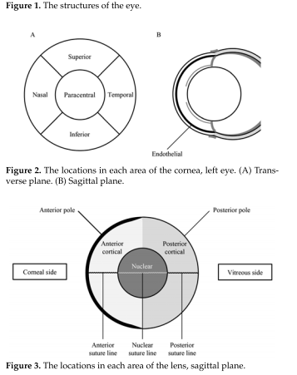

Importance and Recommendation: The findings indicates that regular verification and updating of historical control data is critical to ensure experimental validity and current results provides useful information for toxicologists and ophthalmologists in assessing ocular toxicities of drugs and chemical . ocular historical control data should be updated regularly in the laboratory or facility.

QUESTIONS
- T or F. Corneal opacity seen in Sprague-Dawley rats are influenced by genetic factors, age, environment , infectious disease, and trauma
- T or F. retinal folds are uncommon abnormality in young Sprague-Dawley Rats
- A congenital abnormality wherein abnormal arrangement of the outer nuclear layer is seen microscopically.
- Posterior synechia
- Choroid hyperreflectivity
- Lenticular fold
- Retinal Fold

ANSWERS
- True
- False - based on the data, retinal folds are common in young SD rats
- d

Denk et al. Retinal Features in Cynomolgus Macaques (Macaca fascicularis) Assessed by Using Scanning Laser Ophthalmoscopy and Spectral Domain Optical Coherence Tomography, pp. 145-151

Domain 3 Research
Primary Species: Macaques (Macaca spp.)

SUMMARY: Optical coherence tomography (OCT), a noninvasive imagine technique, provides high-resolution images of different ocular structures, and helps with the diagnosis of ocular problems; most commonly used for imaging of the retina and the optic nerve. OCT examination of cynomolgus macaques is currently used in preclinical toxicology studies, however, there is no clear standards regarding imagining technique or interpretation of OCT scans causing considerable variability among different animals. The researchers provide new insights of retinal findings that can be observed on OCT in untreated cynomolgus macaques.

Retrospective data analysis was performed from studies conducted in the routine support of pharmaceutical product development; the data included 192 female and 192 male macaques. OCT images were averaged for 10 to 30 scans; and image analysis was performed by 2 independent readers. Remarkable findings included the presence of elongated remnants of the hyaloid artery (Bergmeister papilla) and intravitreal hyperreflective spots (HRS). Bergmeister papilla was found in 42.7% of the eyes in scans that included the optic disc and 79% of macaques whose scans included the optic disc showed this finding on at least one eye; males were affected significantly than females. SD-OCT revealed HRS in the vitrus of 42.4% of the eyes scanned; these lesions were round to oval in appearance, some were displayed comma-shaped tails or were tapered at one end. Also, two macaques showed bilateral retinal vessel tortuosity; six macaques presented bilateral symmetrical, significantly larger foveal pits compared with other animals.

HRS spots were more common in female animals whereas male macaques were affected with Bergmeister papillae more often than females. Intravitreal HRS is not normal in human population, it is associated to ocular inflammatory diseases, ocular trauma, and seems to represent intravitreal cellular infiltrates or blood cells; however, in these macaques ocular examinations did not reveal any indication of associated inflammatory changes or signs of ocular trauma. Remnant of Bergmeister papilla did not regress completely in many eyes of cynomolgus macaques; in humans regression of the hyaloid vasculature network (Bergmeister papilla) is normally completed by birth. Researchers suggest that the presence of Bermeister papilla in macaques should be considered as an anatomic variant rather than an abnormal finding in this species. Retinal vessel tortuosity is commonly associated to ocular inflammation and ischemic retinal disorders; these macaques presented dilated venous retinal vessels and tortuosity; however, the significance of retinal artery tortuosity remains unclear. As for the fovea, an alteration related to the shape is usually associated to aging or disease but in macaques future studies are needed for more detail assessment of foveal curvature and symmetry. Finally, more refinement and standardization of ocular imaging in the preclinical setting will maximize the potential use of OCT scans.

QUESTIONS (True or False)
1. OCT provides a real-time cross-sectional imaging of ocular structures, most commonly used of the retina and the optic nerve.
2. Changes in the vitreous filaments most often are a result of aging but can originate from inflammation, vitreoretinal dystrophies, or myopic and diabetic vitreopathy.
3. Bergmeister papilla is it considered an abnormality in macaques.

ANSWERS
1. True
2. True
3. False. It should be considered an anatomical variation in macaques.

Kendricks et al. Reproductive Outcomes in Rhesus Macaques (Macaca mulatta) with Naturally-acquired Trypanosoma cruzi Infection, pp. 152-159

Domain 1; T3
Primary Species: Macaques (Macaca spp.)

SUMMARY: Chagas disease is caused by the protozoan parasite, Trypanosoma cruzi and transmitted via insects in the Reduviidae family, commonly known as kissing bugs. Transmission is through contact with T. cruzi trypomastigotes in the feces of the reduviid bug via blood-feeding bite wound, mucous membrane contact, or ingestion. An approximate rate of 5% has been found of congenital transmission. The disease is usually asymptomatic but can result in myocarditis or meningoencephalitis. Cardiac manifestations are a common chronic clinical sign; gastrointestinal disease is less common. Seropositivity in Southern US outdoor housed NHPs ranges from 2.0% to 22.5%. The current study showed that juvenile and weanling NHPs had low seroprevalence, suggesting that congenital infection is most likely low. Certain T. cruzi strains appear to be more likely to transmit congenitally in certain areas. For example, in Argentina, Honduras, and Mexico, found that DTU TcI were the least likely strain to play a role in congenital transmission and DTU TcIV has also been shown to be a low likelihood of congenital transmission. In this study, the most common DTUs were TcI and TcIV, making congenital transmission a low likelihood. Screening tests were performed using the Tc24 antigen ELISA. The Tc24 antigen has homologues in other members of the Trypanosomatidae family, so a specific T. cruzi test, the Chagas Stat Pak was also used. Earlier testing included Multiplexed Fluorometric ImmunoAssay (MFIA).

QUESTIONS
- What vector transmits Trypanosoma cruzi?
- How is T. cruzi transmitted?
- What is the most common chronic clinical sign associated with Chagas disease?

ANSWERS
- The protozoan parasite, known as the kissing bug in the Reduviidae family
- Transmission is through contact with T. cruzi trypomastigotes in the feces of the reduviid bug via blood-feeding bite wound, mucous membrane contact, or ingestion.
- Cardiac manifestations

Magden et al. Comparative Analysis of Cellular Immune Responses in Conventional and SPF Olive Baboons (Papio anubis), pp. 160-169

Domain 1
Secondary Species: Baboon (Papio spp)

SUMMARY: Most baboons used in research are maintained under conventional conditions. Under these conditions, baboons may harbor viruses that do not cause disease in immunocompetent animals but may interfere with immunologic studies including vaccine development. The use of SPF baboons has been suggested to combat the risk of possible research complications associated with using conventional animals. Studies thus far typically use conventional animals, raising the question of whether cellular immune responses differ between SPF and conventional baboons. This study compares normal immune cell parameters between age-matched conventional and SPF olive baboons.

Conventional and SPF baboons were found to have equivalent numbers of helper and cytotoxic T cells. Expression of CD4+ central memory, and CD8+ effector memory T cells was significantly greater in conventional compared with SPF baboons. Significant increases in circulating TNFα were found in SPF after mitogen stimulation compared with conventional baboons where as IL2, IL6, IL10, IL12 (p40), and IFNγ did not differ between groups. Exposure of PBMC from conventional baboons to various Toll-like (TLR) ligands, (TLR3, TLR4, and TLR8), resulted in an increased numbers of IFNγ producing cells, whereas PBMC from SPF baboons stimulated with TLR5 or TLR6 ligand had more IFNγ-producing cells.

Conclusion: Although lymphocyte subsets of conventional and SPF baboons share many phenotypic and functional similarities, findings from this study suggest that specific differences in lymphocyte immune function exist that may alter innate and adoptive immune responses. Differences should be considered when interpreting experimental outcomes associated with immune responses.

QUESTIONS
- Which of the following is not a function of NK cells?
  - First line of defense against virus-infected cells and tumor cells
  - Important mediator of transplantation rejection reactions
  - Secrete cytokines such as IFNγ and TNFα, which act on other immune cells like Macrophage and Dendritic cells to enhance the immune response
  - Release cytotoxic granules containing perforin and granzymes, which leads to lysis of a targeted cell
  - Present antigens to T cells
- _______ is not an excluded pathogen in SPF colonies of baboons.
    - (Herpesvirus papio types 1 and 2)
    - Simian varicella zoster virus
    - Human herpesvirus type 6
    - Human herpesvirus type 1 and 2
    - Simian foamy virus

ANSWERS
  - e
  - d

Kinaci et al. Histologic Comparison of the Dura Mater among Species, pp. 170-175

Domain 3: Research; Task T3. Design and conduct research

SUMMARY: The authors examined the dura mater, which was harvested parasagittally from 11 different species. The comparison of dural thickness, number of layers, fibroblast orientation stratified by layer, if distinguishable, is found below in table 1.

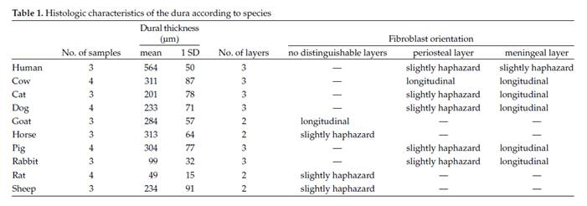
Figures showing dura mater from each species, with the layers delineated.

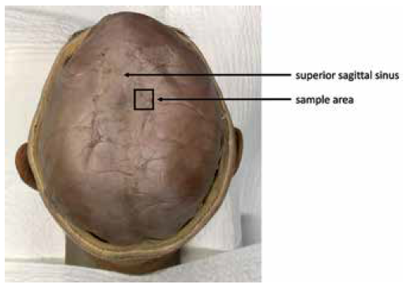 | Figure 1. As shown in the figure, the dura was harvested parasagittally  in all species.
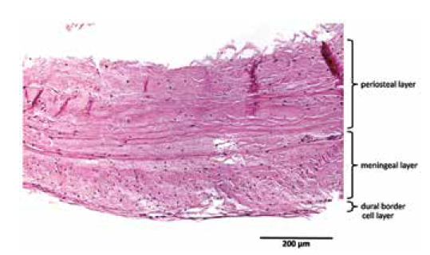 | Figure 2. Human dura mater.
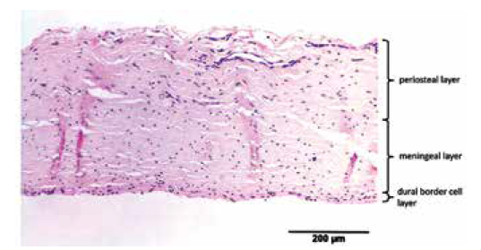 | Figure 3. Bovine dura mater.
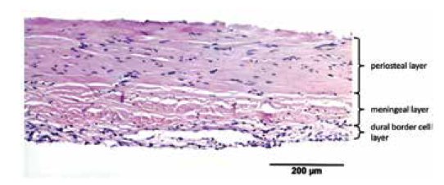 | Figure 4. Canine dura mater.
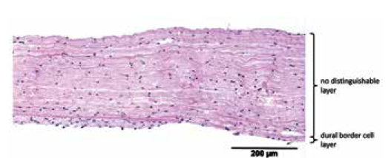 | Figure 5. Caprine dura mater. The DBC layer is partially visible.
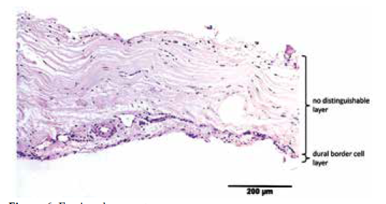 | Figure 6. Equine dura mater.
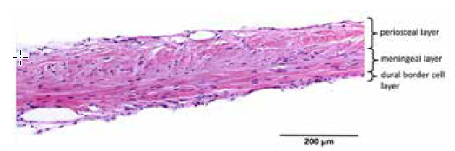 | Figure 7. Feline dura mater.
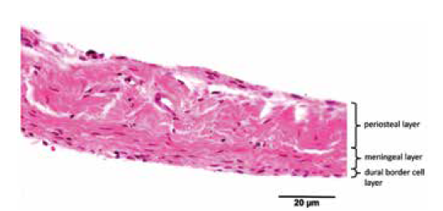 | Figure 8. Leporine dura mater.
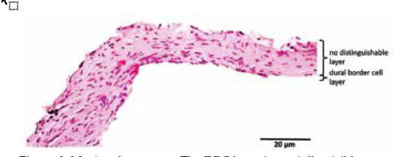 | Figure 9. Murine dura mater. The DBC layer is partially visible.
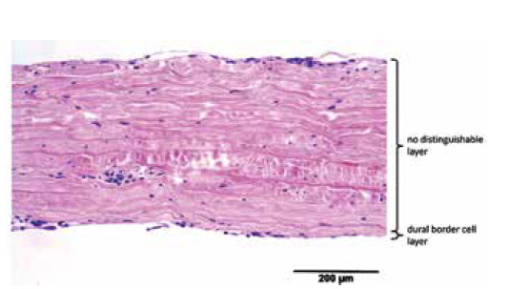 | Figure 10. Ovine dura mater. The DBC layer is partially visible.
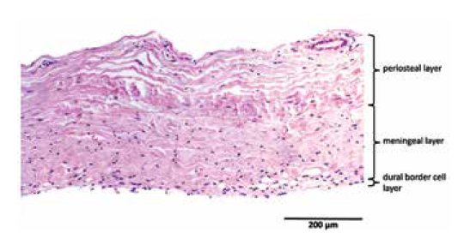 | Figure 11. Porcine dura mater. The DBC layer is partially visible.

QUESTIONS
- Which of the following species has the thickest dural thickness?
a. Cat
b. Cow
c. Human
d. Pig

- Which of the following species has only 2 layers in the dura mater?
a. Cow
b. Human
c. Rat
d. Dog

ANSWERS
1. c
2. c

CASE STUDIES

Oatess et al. Severe Periocular Edema after Intracranial Carboplatin Chemotherapy for Retinoblastoma in a Rabbit (Oryctolagus cuniculus) Model, pp. 176-182

Domain 3: Research
Primary Species: Rabbit (Oryctolagus cuniculus)

SUMMARY: Retinoblastoma is the most common primary intraocular malignancy in infants and children. Local routes of chemotherapy delivery are relatively new but being widely adopted. The rabbit is the only current small animal model for endovascular microcatheter-based intraarterial (ophthalmic artery) chemotherapy (IAC). Using fluoroscopy, a microcatheter is passed through the femoral artery to the ophthalmic arterial blood supply. The mainstay of this treatment in humans has been melphalan which can cause local ocular and vascular adverse events.

Carboplatin was delivered in a pulsatile fashion to maximize amount of drug delivered to the central retinal artery instead of being carried into smaller side vessels which would be expected from continuous pump infusion. 3 animals received 50 mg carboplatin but developed severe, bilateral periocular edema in less than 4 hours after treatment and were humanely euthanized. A second cohort 5 months later resulted in 4 animals receiving 25 mg carboplatin, but 3 of 4 developed periocular swelling approximately 24h after treatment. One died 72h after treatment due to causes unrelated to IAC. Of the remaining 3, two were euthanized shortly after signs were noted and the last animal was medically managed for 5 days before being euthanized. Overall, 10 of 12 eyes from animals treated unilaterally with carboplatin developed severe unilateral (n=2) or bilateral (n=4) periocular edema. Lesions were alike in treated (right) eyes and similar but less severe in the affected but untreated (left) eyes. Histopathological findings in the 50 mg group included marked edema of bulbar and palpebral conjunctiva, extraocular muscles, and choroid with fibrin exudation, congestion, and mild heterophilic infiltrates with no evidence of vasculitis. In the 25 mg group, histopathology showed similar findings with the addition of more temporally advanced lesions including heterophilic choroiditis, multifocal endoarteritis, and coagulation necrosis in lobes of the Harderian gland. In the animal treated for 5 days, lesions had progressed to include necrotizing arteritis, venous thrombosis, coagulation necrosis in lobes of the Harderian and lacrimal glands, and retinal detachment, degeneration, and necrosis.

These findings suggest an underlying pathogenesis of drug-induced arteritis and vasogenic edema with swelling of orbital structures perpetuating circulatory compromise and causing further ischemic damage. The most common adverse event after IAC in humans is self-limited eyelid edema or localized skin erythema. Periocular swelling in humans is not considered to be painful and the condition is left to resolve on its own. Eyes usually swell shut in humans in contrast to rabbits where the periocular edema caused the eyelids to swell and the eye to stay open (lagophthalmos) raising risk of keratopathy. Previous studies using saline have shown that IAC alone is not associated with adverse effects. The authors conclude that species-specific ocular vascular anatomy contributed to complications including interophthalmic artery anastomosis as well as a particular sensitivity of rabbits to the vasotoxic effects of carboplatin. Great caution should be used studying IAC in rabbits using carboplatin.

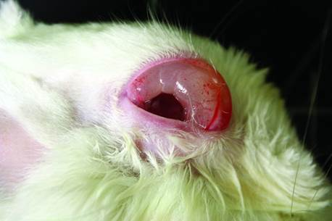

QUESTIONS
- Which species has a higher endogenous thrombin potential: humans, rabbits, rats, sheep, pigs?
- How does carboplatin exert antitumor activity?

ANSWERS
- Rabbits
- Crosslinking DNA (blocking transcription)

Keesler et al. Clinical and Pathologic Features of Spontaneous Klebsiella pneumoniae Infection in 9 Rhesus Macaques (Macaca mulatta), pp. 183-189

Domain 1
Primary Species: Macaques (Macaca spp.)

SUMMARY: Klebsiella pneumoniae is ubiquitous in the soil and water as well as commensal in the upper respiratory and GI tract of many mammals. It is a cause of serious nosocomial infection and has increasing multidrug resistance. It humans it can cause Klebsiella-associated syndromes (KAS) such as liver abscesses, pneumonia, bacteremia, UTI, meningoencephalitis, and endophthalmitis. The hypermucoviscous phenotype (positive string test) is a marker for hypervirulent forms. In animals it is a common cause of mastitis in dairy cows and has been reported in several NHP species such as macaques, African green monkeys, common marmosets, and owl monkeys. African greens seem particularly susceptible, and rhesus and cynomolgus macaques are likely to be subclinical carriers. The objectives of this retrospective case study are to describe the clinical and pathologic features of K. pneumoniae infection in rhesus macaques, to compare these observations to human KAS, and to address risk factors and implications for colony health and experimental protocols.

Between 2010-2015, 28 Klebsiella culture-positive rhesus macaques were identified. 8 had gross and histologic lesions consistent with Klebsiella infection. 1 rhesus macaque was Klebsiella PCR-positive and had consistent histologic lesions. All 9 animals succumbed quickly. Antibiotics administered in 3 cases had no clinical effect.
5/9 animals were euthanized after clinical evaluation (3 geriatric, 1 adult, 1 infant). 1 geriatric animal had been hospitalized for chronic diarrhea and presented with peracute signs on day 34, necessitating euthanasia.

4/9 were found dead (4 infants).

Necropsy Findings
Suppurative peritonitis (n=2)
Gross multifocal hepatic abscesses (n=1)
Histologic multifocal suppurative hepatitis (n=1)
Gross pleuropneumonia or pulmonary abscesses (n=2)
Histologic pneumonia (n=4)
Meningitis (n=4)
Meningoencephalitis (n=3)
Meningomyelitis (n=1)
Optic neuritis (n=3)
Endophthalmitis (n=1)
Bacteremia (n=8)

Culture Results
8 cultures yielded K. pneumoniae with positive string tests
Lung (n=5)
Brain (n=4)
Pleura/peritoneum (n=2)
Nasal (n=2)
Liver (n=1)

PCR Testing
4 paraffin blocks of histologic lesions tested
n=2 were positive for K. pneumoniae, including the animal that was not cultured

Similar to human KAS and previous NHP reports, macaques had pulmonary or hepatic abscesses and bacteremia with meningitis or endophthalmitis or both. No UTIs were identified. In 3 cases, meningitis was present without liver or lung involvement. The 3 geriatric animals had significant comorbidities such as pulmonary Pneumonyssus and thyroid neoplasm, colonic adenocarcinoma and hepatic amyloidosis, & enteric/renal amyloidosis and trauma. All 4 adults were seropositive for endemic viruses such as cytomegalovirus, herpes B virus, and rhesus rhadinovirus.

All cultures yielded the hypermucoviscous phenotype, but virulence factor testing was not performed. Antibiotic sensitivity testing is recommended.

20 animals in this study were considered to be carriers because they were culture-positive but never exhibited clinical signs. Since infection had been shown to alter cytokine response, routine culture is recommended to identify carriers prior to project enrollment.

Klebsiella pneumoniae infection appears to be rare but should be considered in animals with rapidly progressive clinical signs associated with bacterial infection. Prognosis is guarded. Histopathology is reliable for diagnosis. Culture lung and brain of sudden death infants. Utilize string tests, antibiotic sensitivity, and PCR tests for virulence factors.

QUESTIONS
1. T/F: Urinary tract infections were a prominent feature of K. pneumoniae infection in rhesus macaques.
2. What is a phenotypic test for the hypermucoviscous phenotype of K. pneumoniae?
3. T/F: Meningitis was found in rhesus macaques even in the absence of liver or lung lesions.
4. What is the dental formula and gestation period of the rhesus macaque (Macaca mulatta)?

ANSWERS
1. False
2. String test
3. True
4. 2-1-2-3; 164 days

